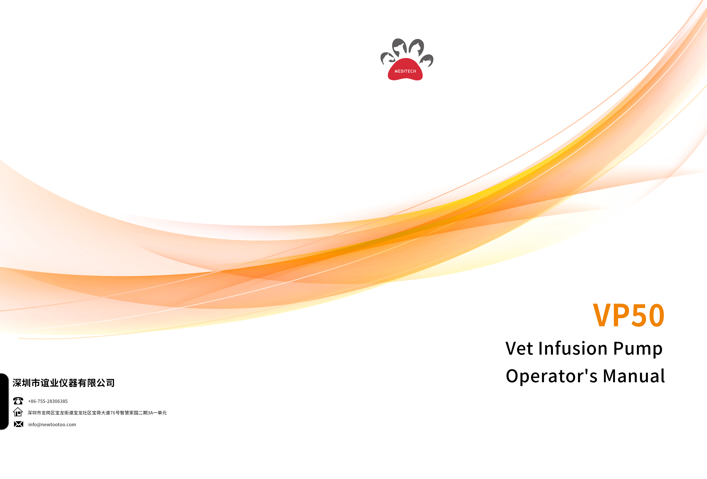

Preface

Manual Purpose
This manual contains the instructions necessary to operate the product safely and in accordance with its function and intended use. Observance of this manual is a prerequisite for proper product performance and correct operation and ensures animal
and operator safety. This manual is based on the maximum configuration and therefore some contents may not apply to your product. If you have any question, please contact us.
This manual is an integral part of the product. It should always be kept close to the equipment so that it can be obtained conveniently when needed.

Intended Audience
This manual is geared for clinical professionals who are expected to have a working knowledge of medical procedures, practices and terminology as required for monitoring of critically ill animals.

Illustrations
All illustrations in this manual serve as examples only. They may not necessarily reflect the setup or data displayed on your equipment.

Conventions
- Italic text is used in this manual to quote the referenced chapters or sections.
- [ ] is used to enclose screen texts.
- < > is used to enclose the keys.
- → is used to indicate operational procedures.

WARRNING
- This product should use by a professional veterinarian or under their instruction.
- The operator should receive a professional training, any unauthorised or untrained personnel shall not carry out any operation.

Content

Preface I
Chapter 1 Safety 1-4
  - Security Information 1-4
    - Danger 1-4
    - Warning 1-5
    - Caution 1-6
    - Note 1-7
  - Equipment Symbol 1-8
Chapter 2 Overview 2-1
  - Description 2-1
    - Scope of Application 2-1
    - Contraindications 2-1
    - Structural Composition and Performance 2-1
  - Host 2-2
    - Front View 2-2
    - Rear View 2-3
    - Top View 2-4
    - Bottom View 2-5
  - Touch Screen Display 2-6
Chapter 3 Installation and Setup 3-1
  - Install 3-1
    - Out of Box Audit (OOBA) 3-1
    - Operating Conditions 3-2
    - Mount the Clamp 3-3
    - Connect to AC Power Source 3-4
Chapter 4 Basic Operation 4-1
  - Infusion Flow Chart 4-1
  - Operation Step 4-2
    - Turn On 4-2
    - Install the IV Set 4-2
    - Replace the IV Set 4-4
    - Replace the Infusion Bottle (bag) 4-5
    - Select Infusion Set Brand 4-5
    - Select Infusion Mode 4-6
    - Purge 4-6
    - Set Infusion Parameters 4-7
    - Infusion 4-7
    - Infusion Pause 4-8
    - BOLUS 4-8
    - Change the Rate during Operation 4-9
    - Infusion Completed 4-9
    - Standby 4-10
    - Shutdown 4-10
Chapter 5 Infusion Mode 5-1
  - Rate Mode (VP50) 5-1
  - Time Mode (VP50) 5-1
  - Body Weight Mode (VP50) 5-1
  - Sequential Mode (VP50) 5-2
  - Drip Setting (VP50) 5-2
Chapter 6 General 6-1
6.1 KVO 6-1
  - Occlusion Pressure 6-1
    - Select Occlusion Pressure 6-1
    - Set Unit of Pressure 6-2
    - Dynamic Pressure Detection (DPS) 6-2
    - Automatic Pressure Release (Anti-Bolus) 6-2
  - Bubble Size 6-2
  - Cumulative Bubbles 6-3
  - Key Lock Function 6-3
  - Reminder Function 6-3
  - Time Near End 6-4
  - Infusion IV set Brands 6-4
  - Cumulative Amount Reset 6-4
Chapter 7 System 7-1
  - Sound Adjustment 7-1
  - Adjust Screen Brightness 7-1
  - Bed Number Setting 7-1
  - Set Date and Time 7-1
  - Language Setting 7-1
  - History Record 7-1
Chapter 8 Alarm 8-1
  - Alarm Level 8-1
  - Alarm Type 8-1
    - Multi-Level Alarm Rules 8-2
  - Alarm Handling Rules 8-2
  - Alarm Countermeasures 8-2
  - Alarm Information 8-3
Chapter 9 Battery 9-1
  - Check Battery Performance 9-2
  - Install the Battery 9-2
  - Battery Recycling 9-2
Chapter 10 Preservation and Sanitation 10-1
  - Description 10-1
  - Cleaning 10-1
  - Disinfection 10-2
Chapter 11 Maintenance 11-1
  - Inspection 11-1
  - Maintenance Plan 11-1
  - View Information 11-2
  - Restore Factory Setting 11-2
  - Safe Disposal and Recycling 11-2
Chapter 12 Accessories 12-1

A Product Specifications ..............................................................................................................A-1
A.1 Safety Specifications.......................................................................................................A-1
A.1.1 Product Classification ................................................................................A-1
A.1.2 Operating Environment .............................................................................A-2
A.2 Physical Specifications ....................................................................................................A-2
A.3 Hardware Specifications .................................................................................................A-2
A.3.1 Display .......................................................................................................A-2
A.3.2 Battery .......................................................................................................A-3
A.3.3 Host LED ....................................................................................................A-3
A.3.4 Auditory Indication ....................................................................................A-3
A.3.5 Interface ....................................................................................................A-3
A.3.6 Signal Output.............................................................................................A-3
A.4 Specifications..................................................................................................................A-4

B Default Factory Setting ............................................................................................................. B-1

C Symbols and Terms ...................................................................................................................C-1
C.1 List of Units ..................................................................................................................... C-1
C.2 Technical Alarm Message ............................................................................................... C-2
C.3 List of Terms.................................................................................................................... C-2
C.4 List of Unit Conversion.................................................................................................... C-3

D Toxic and Hazardous Substances or Elements .........................................................................D-1

Chapter 1 Safety

Security Information
This section lists basic safety information that operators must pay attention to and follow when using the infusion pump. The same or other safety information related to specific operation will appear in each chapter.

 WARNING
- Indicates a potential hazard or unsafe practice that, if not avoided, could result in death, serious injury or damage to product/property.

CAUTION
- Indicates a potential hazard or unsafe practice that, if not avoided, could result in minor personal injury, product malfunction or damage to product/property.

NOTE
- Provides application tips or other useful information to ensure that you get the most out of the product.

Danger
There is no information on hazard levels in this manual.

Warning

 WARNING
- Equipment, cables and accessories must be inspected before use to guarantee their normal and safe operation.
- This equipment can only be connected to the socket with ground protection. Please adopt a rechargeable battery instead of the socket as the power supply if the socket is not provided with a ground lead.
- To prevent fire or explosion, do not operate the equipment in the presence of anesthetic, flammable or explosive materials.
- Do not open the equipment casing as there is the impending danger of electric shock. Equipment maintenance and upgrades must be carried out by maintenance technicians whom are trained and licensed by the manufacturer. Moreover, the process must be done only after the AC power supply is disconnected. Maintenance carried out by individuals non-affiliated to the manufacturer or by non-licensed personnel may affect the safety, performance and function of the product.
- When used with electrosurgery equipment, the safety of animals should be ensured.
- The animal’s clinical condition and the working condition of the pump must be monitored carefully, the alarm sound and alarm levels need to be set according to the actual needs. Operation and performance relying solely on the auditory alarm system alone is not sufficient, and setting the alarm at a low sound may endanger the animal. If the alarm sound is less than the surroundings sound, which can further lead to operators identify alarm mistakenly.
- The interconnection of other infusion systems or ACCESSORIES to the ANIMAL LINE may lead to performance degradation and failure to achieve the expected performance, the working condition of the pump and animal's clinical condition shall be monitored regularly.
- Please carefully install the power line and cables with various accessories to prevent the animal from choking or suffocation caused by entanglement of the cables or by electrical disturbance.
- The packaging materials must be disposed of in compliance with local laws and regulations or the hospital policy on waste management. They must be kept out of the reach of children.
- Line kinks, filter coagulation and occlusions arising from needle insertion can cause the pressure inside the syringe or infusion set to rise during infusion.
- When this occurs, removing the occlusion can cause excessive liquid to be infused into the animal, so appropriate measures should be taken.
- The pump must be mounted at the animal’s heart level. The most accurate pressure monitoring in the extension set is achieved when the pump is positioned close to the

animal’s heart level. Adjust the height of the pump so that there is 51±5 cm between the fluid line and the middle of the pump.
      - When operating the pump and under non-running status, please carefully check whether there is leakage from the line export of the infusion set, and drop needle of the drip chamber. If any leakage is found, please contact the manufacturer for maintenance and confirmation.
      - Do not touch the animal when connecting the peripheral equipment via the input/output signal ports to prevent animal leakage current from exceeding the requirements specified by the standard.
      - In the process of defibrillation, do not touch animal and other non-defibrillation equipment to prevent electric shock damage, and defibrillation will not affect the basic performance (such as infusion accuracy, alarm and signal transmission) of the pump.
      - The equipment uses a main plug as isolation means to the mains power. Do not locate the equipment in a place difficult to operate the mains plug.

Caution

CAUTION
- Please use the accessories specified in this manual for animal safety.
- When the infusion pump or accessories are about to exceed their service life, they must be discarded in accordance with relevant local regulations or hospital regulations. If you have any questions, please contact the dealer or manufacturer who sold this product to you.
- After the infusion set is installed, please pay attention to observe whether there is any leakage before starting the infusion. If there is leakage, check and deal with it in time.
- If the infusion is more than 4 hours, it is recommended to replace the infusion IV set or adjust the position of the infusion set to ensure accuracy; it is recommended to test the service life of the IV set to determine the time interval for changing the clamp tube position, if not tested, it is recommended Adjust the infusion set pinch position every
2-4 hours to ensure accuracy.
- Electromagnetic fields can affect the performance of this equipment, so other equipment used in the vicinity of this equipment must meet the appropriate EMC requirements. Mobile phones, X-rays or MRI equipment are all possible sources of interference, as they all emit high levels of electromagnetic radiation.
- Please verify that the voltage and frequency of the power source meet the requirements specified on the device's label or in this manual before connecting the power supply.
- Please install or carry the infusion pump properly to prevent the device from falling,

bumping, being damaged by strong vibration or other mechanical external forces.
      - They should be disposed of in accordance with the relevant regulations of animal hospitals and veterinary stations after the disposable accessories are used up.
      - The infusion pump should be protected from direct sunlight, high temperature and humidity.
      - Please check the battery to make sure it has sufficient power before working with the built-in battery. Recharge the battery if needed.
      - It is recommended to use a syringe with a luer connector, which can effectively prevent the infusion line from falling off after being pulled under tension, resulting in underflow.

Note

NOTE
- Install the equipment in a position where it can be easily accessed for inspection, operation and maintenance.
- Keep this Operator's Manual near to the equipment for future ease of reference.
- The software was developed in compliance with IEC62304.
- This Operator's Manual describes the most complete functional.
- Configuration of the equipment. The product you are using may not have some of the settings or functions described herein.
- Do not insert equipment that are not specified by the manufacturer into the multifunction connector.
- During infusion, the pump can accurately control the rate, infusion volume and infusion time, and monitor the operation in real-time, to effectively prevent over currents, under currents and instances of backflow.
- The equipment is not in touch with the drugs or animals directly. Thus, there is no need to process Biocompatibility test on it.



Equipment Symbol
The device you purchased may not have all of the symbols below.

I 
 | Notice!  Refer to the accompanying documents (this manual) |  | On/Off
 | Alternating Current (AC) |  | Battery
 | Alarms |  | Audio Pause
 | Start/Bolus |  | Stop
 | Wireless networking |  | Lock
P34 | Anti-solid foreign objects with a diameter of not less than 2.5mm,  splash-proof |  | Defibrillation proof CF type applied part
 | Night mode |  | Manufacturer
 | Date of manufacture |  | Non-ionizing electromagnetic radiation
 | Dispose of using pollution-free methods |  | Serial number
 | External interface |  | CE Mark
 | European Community Representative Office |  | Recycle
 | Environmental protection service life of electronic products (20 years) |  | The humidity limit of the transport package is 10%~95%




 | The environmental  pressure limit of the transport package is 50~106kPa |  | Infusion set
 | The temperature limit of the transport package is -20 to 60ºC |  | Avoid rain
 | UP |  | Stacking layer limit
 | Fragile, handle with care

Chapter 2 Overview

Description

Scope of Application
This infusion pump for use in animal hospitals and veterinary stations for constant-rate intravenous infusion of liquid medicines to animals.

This infusion pump is suitable for all animal hospitals, veterinary stations and zoos or pet care centre.

 WARNING
- This infusion pump is used for animal infusion or injection and is only allowed to be used by professional veterinarians, medical electrical specialists or professionally trained veterinarians. Personnel using this infusion pump should receive adequate training. Any unauthorised person or untrained person shall not carry out any operation.

Contraindications
None

Structural Composition and Performance
The infusion pump is mainly composed of a host and an internal rechargeable battery. The eccentric camshaft is driven by the stepper motor to rotate in working state, so that the slider fixed on it reciprocates up and down according to a certain sequence and movement law, and the IV set is squeezed regularly, so that the liquid in the IV set is oriented at a certain speed rate and all parts are suitable for use in animal environments. Infusion pump functions include: Rate mode, history, Anti-bolus, etc.
Because some parts are optional parts, the infusion pump you purchased may not have some parts and their corresponding functions.

Host

Front View

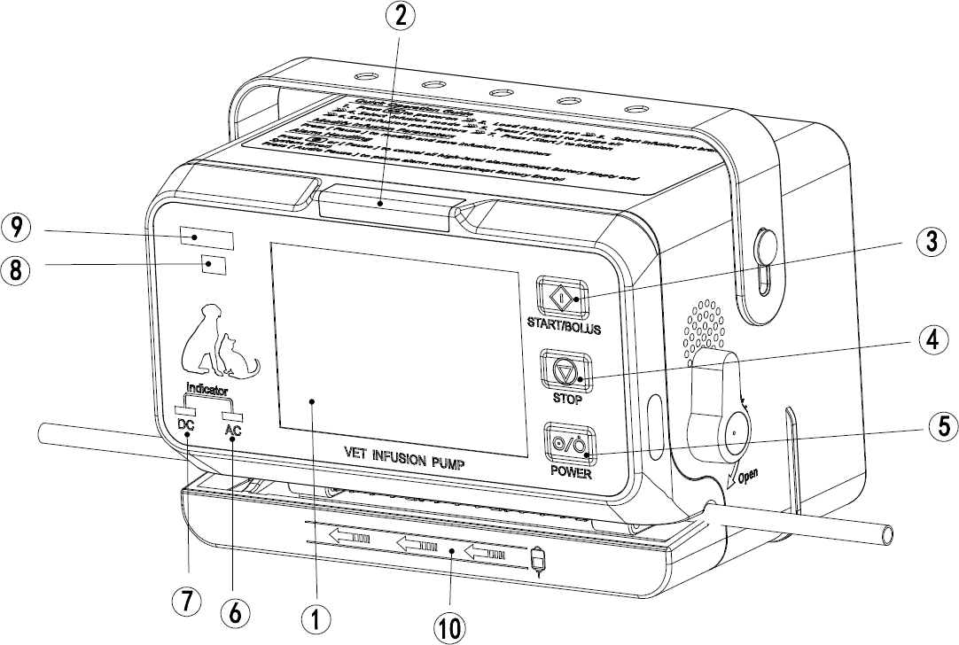

      - Touch Screen Display
- Used to display infusion parameters option control and related content.
      - Alarm Indicator
- The alarm indicator indicates the level of alarm with two colors LED lights and flashing frequencies. when the pressure and bubble sensing exceed the set range and other abnormal conditions.
      - <Start/Bolus Button>
- Press this Button to start the infusion or purge after installing the infusion set correctly and setting the infusion parameters.
- Press and hold this Button to manual bolus after setting [Bolus rate], and release to return to the original rate.
      - <Stop Button>
- During infusion, press this key to stop infusion. Infusion stops caused by alarms (such as Occlusion), press this key to cancel the alarm.
      - <Power Button>
- Used for power-on, standby and shutdown operations.
      - AC Power Indicator
- Indicator On: The infusion pump is connected to AC power.
- Indicator Off: The infusion pump is not connected to AC power.
      - DC Power Indicator

- Indicator On: Steady green: The battery is charging (including shutdown).
- Indicator Flashing: The pump is running on battery power.
- Indicator Off: There is no battery or the battery is not working.
      - Product Model
- Only apply to this company.
      - LOGO/TRADEMARK
- Only for our company.
      - Infusion Direction
- Informs the operator on the proper direction of flow for infusion setup.

Rear View

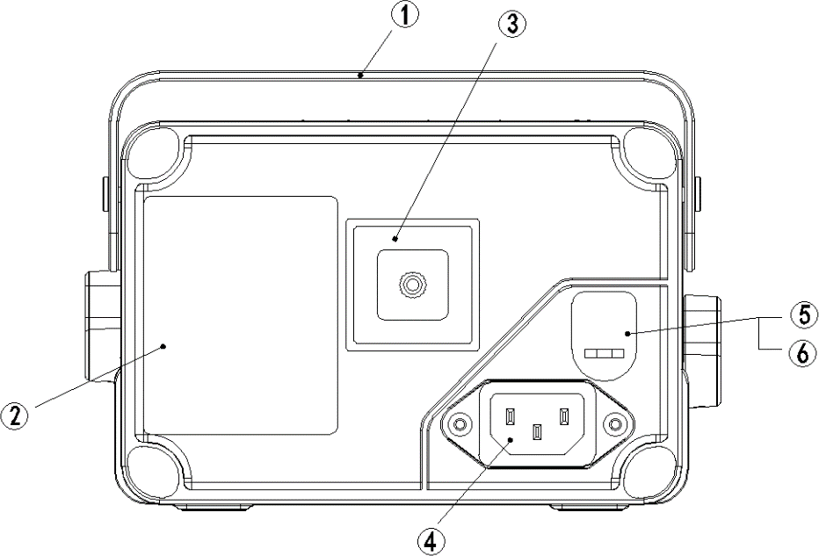

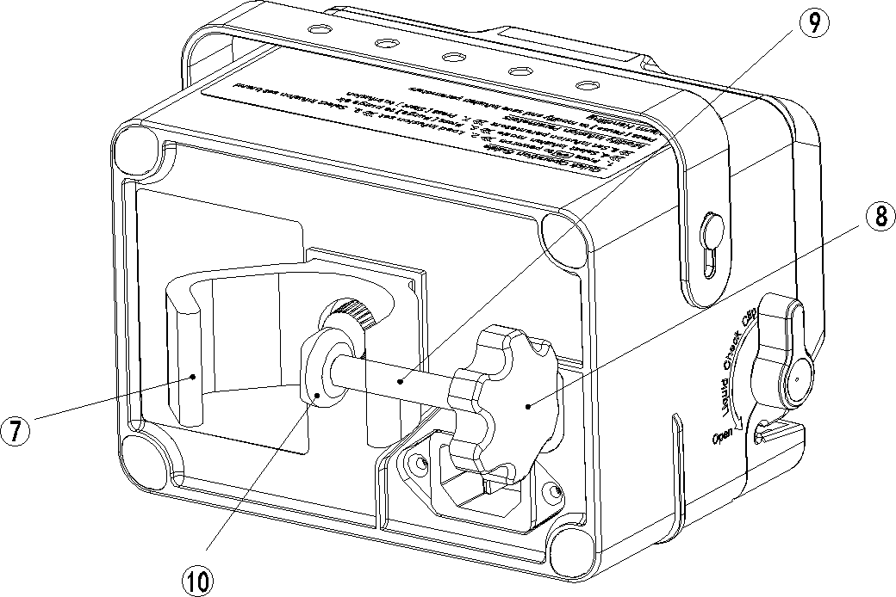

      - Handle
- TPU material, its use for carrying the pump easily.
      - Nameplate
      - Fixing Clip Installation Position
      - AC Power Connector
      - DC12V Power Interface
      - Interface Waterproof Rubber Plug
      - Pole Clamp
- The device is fixed on an infusion pole or a hospital bed frame.
- The fixing clip can be manually adjusted and rotated 90° to fix the device horizontally and vertically.
      - Pole Clamp – Manual Knob
- Turn clockwise to lock, counterclockwise to unlock.
      - Pole Clamp – Manual Screw
- Use to install or remove retaining clips.
- Adjust the fixing clip and use it in a fixed direction.
      - Pole Clamp – Collet
- The collet is for fixed and prevented from falling off.

Top View

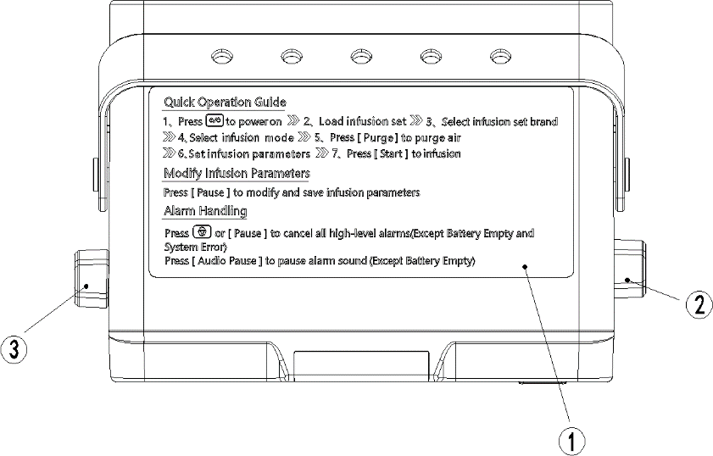

      - Quick Operation Guide Sticker
      - IV Set Knob
- Rotate the IV Set Knob backward 90° to open the tubesheet and forward to closed.
- When the tubesheet is closed, the Liquid Check Clip is opened; when the tubesheet is opened, the Liquid Check Clip is closed.
      - Liquid Check Clip
- Rotate the Liquid Check Clip backward 90° to open and forward to close.
- When the tubesheet is closed, the Liquid Check Clip is open. When opening the tubesheet, the Liquid Check clip can be opened manually.

Bottom View

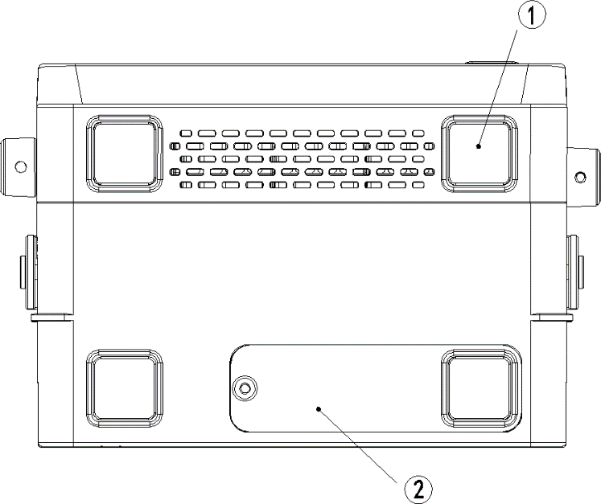
      - Non-slip Feet
      - Battery Slot

Touch Screen Display
This infusion pump uses colorful touch screen LCD; the display content is mainly composed of three parts:

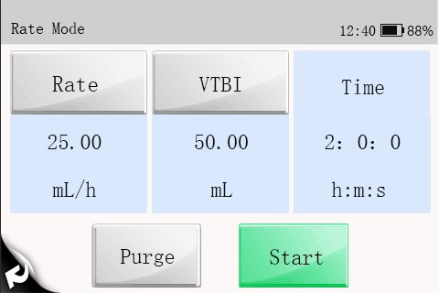
1

2

3

    - Title
Displays the current mode name, battery icon, alarm information, etc.
    - Information Area
Display each parameter and parameter value of the current interface.
    - Function Area
Displays functions such as running, Purge, return, page change, etc.

Chapter 3 Installation and Setup

3.1 Install

WARNING
- Equipment assembly and refit (including correct protective grounding connection) during life period must be carried out by maintenance technicians whom are trained and licensed by the manufacturer, and evaluated according to the specified IEC60601-1. Please contact the company if you have any queries.
- The software copyright for this equipment belongs to the manufacturer. Unless explicitly authorized, any alteration, reproduction or sale by any means or in any form by any organization or individual is prohibited.
- All the analog equipment and digital facilities should be certified according to the specified IEC standard (such as: IEC60950 Information Technology Equipment Safety and IEC60601-1 Medical Electrical Equipment Safety). Moreover, all equipment should be connected based on the requirements of the valid version of the IEC60601-1 system. The qualified individual responsible for connecting auxiliary equipment to the input and output signal ports is also accountable for making the system in accordance with the IEC60601-1 standard. Please contact the company if you have any queries.
- When this equipment combining with other electrical equipment forms a combination with a special function, and the operator cannot determine whether there is an impending danger from each equipment specification (such as a danger of electric shock due to aggregation of current leakage), please contact the company or a specialist in the field at the hospital, to guarantee that all equipment in the combination are safe enough and will not be damaged.
- Please make sure this equipment is securely fixed and positioned. Positioning changes and severe shock can lead to minor changes in the delivery accuracy.

Out of Box Audit (OOBA)
Please check the packing case carefully before opening the box. If there is any damage, please contact the distributor or manufacturer immediately.
Please carefully remove the equipment and its accessories from the packaging in a correct manner, and inspect them against the packing list. Examine the equipment for any mechanical damage and ensure that the box includes all items on the packing list. Please contact the manufacturer if you have any queries.

NOTE
- Keep the packing case and packaging materials for future transportation or storage.

WARNING
- The packaging materials must be kept out of the reach of children. They must be disposed of in compliance with local laws and regulations or the hospital policy on waste management.
- The equipment may be contaminated by microbes during storage, transport and use. Please ensure that the package is undamaged before using, do not use if there is any damage.

Operating Conditions
The operating environment of this equipment must meet the requirements in A.1.2 Operating Environment.
The operating environment should also be appropriately protected from noise,
vibration, dust, and corrosive, inflammable or explosive substances. If installed inside the equipment case, a sufficient space before and after the equipment case should be ensured to facilitate operation, maintenance and repairing work. There should be a 2" (5 cm) gap around the equipment to ensure that air can circulate freely for a better cooling effect.
When the pump is transferred from one place to another, differences in temperature and humidity can cause condensation to form inside the pump. If this occurs, do not switch the pump to the "ON" state until the condensation has gone.

WARNING
- Please use only when the operating environment meets the requirements specified above. Otherwise, the pump's performance will not match the technical specifications in A Product Specifications. Equipment failure and other unexpected consequences may also result.

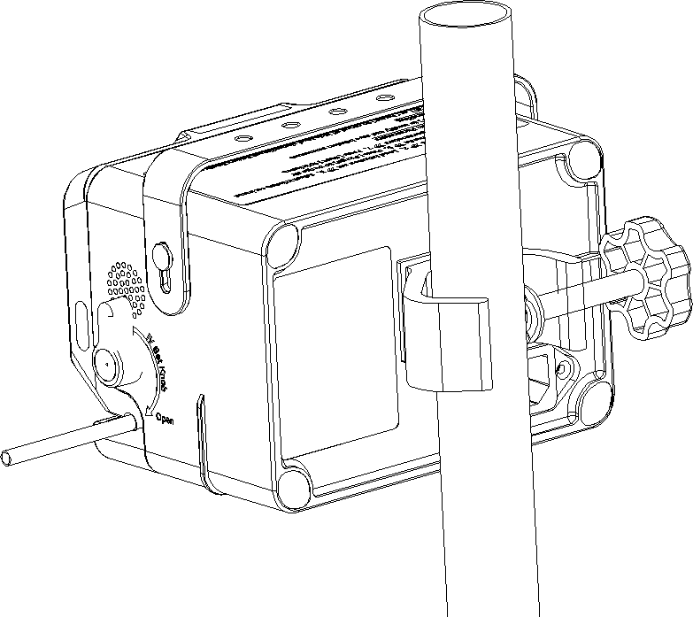
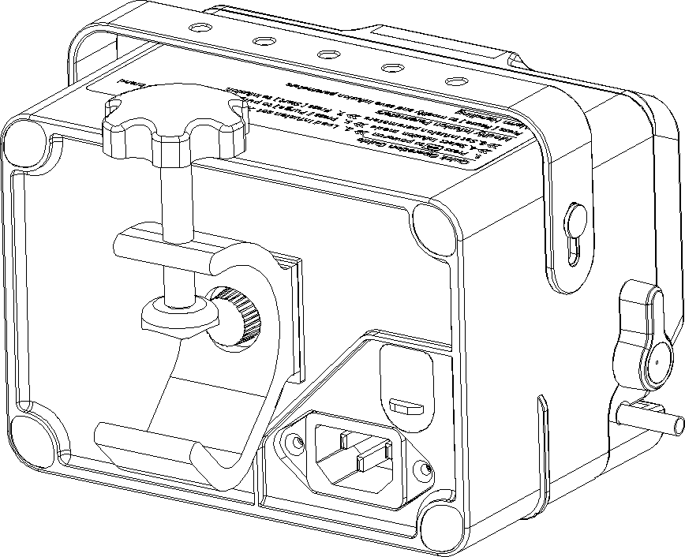

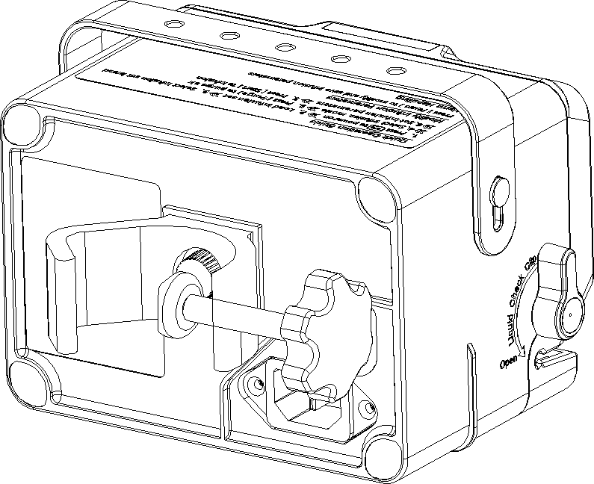
Mount the Clamp

1. Turn counterclockwise to
loosen the pole clamp until an IV stand can be inserted in.
2. Tighten the pole clamp clockwise to firmly fix the device on the IV stand (round vertical bar with diameter size of 15-32mm).
3. Rotate the pole clamp it can be horizontal fix the pole.

WARNING
- The infusion pump must be used in a horizontal position.

NOTE
- Please check the stability of the pole clamp before fixing the infusion pump.

Connect to AC Power Source
      - Make sure to use the original three-core power cord.
      - Plug one end of the power cord into the AC outlet located on the rear panel of the infusion pump.
      - Plug the other end into a matching, AC-powered three-wire outlet.

WARNING
- The earthing wire in the three-plug connector should be grounded, if there is a doubt whether the AC power system is grounded or not, please adopt the built- in battery and contact an electrical technician at the hospital or the company.
- Do not touch the power plug with wet or moist hands! If there is a liquid drug or residue on or around the both ends of the power cord, power socket or plug, device's AC power supply port, the operator should completely clean and dry the area before plugging into the power supply, or accidents or injuries may result!
NOTE
- Compatible power supply: 100-240V ～, 50/60Hz.
- The AC power cord should be correctly inserted and secured into the socket.
- Removing power cord is to disconnect equipment from power supply. Please ensure suitable clearance around the device to facilitate connect and remove power cord.

Chapter 4 Basic Operation

Infusion Flow Chart




Press Power on, the infusion pump self-checks, and the screen displays the LOGO brand and System Self- test interface.

Remove infusion set

Fin ished

Start infusion

Connect to animal

Set infusion parameters

Purge air

Select infusion mode

Select brand

Load infusion set

Turn pump on

Turn pump off

Refer to 4.2.2 Install the IV Set.

Choose built-in brand or operator-define infusion set used.

Select the infusion mode as needed.

Refer to 4.2.7 Purge .

Refer to 4.2.8 Set Infusion Parameters.

Connect to animal.

Press or screen’s [Start] to control infusion.

Press or screen’s [Pause] to stop.

Close the Robert clip (or flow regulator) of the infusion set, disconnect it from the animal, open the IV set knob firstly, and then open liquid check clip, and remove the infusion set correctly.

Press , and click the [Shutdown] on the [Shutdown Selection] interface.

Operation Step

Turn On

Please refer to the following steps to turn on the infusion pump:

      - Before starting the machine, refer to 11.1 Inspection for safety inspection.

      - Press the power button, the system will perform self-test, and the screen will display the [System Self-Test] interface:
        - The alarm indicator light turns on from red to yellow and then goes out - the self-test of the alarm light is successful.
        - The self-test of system is successful after a beeping sound.
        - The system emits a "beep beep" sound -- the buzzer self-test is successful.
      - It will enter the operation interface after the system self-test is successful, which can be operated through the touch screen or keypad.
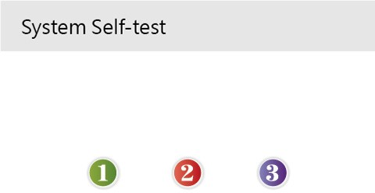

WARNING
- Please monitor the self-test process to make sure that the speaker, the alarm light, and the buzzer are all self-tested successfully. Otherwise, please contact the company and do not operate the pump until maintenance is performed.
- Please contact the company if the infusion pump is damaged or cannot operate properly, and it cannot be used for animal infusion.

Install the IV Set
The system will check whether the infusion set was installed after pass the self-test: It will enter the [Select Brand] interface if an IV set was installed;
It will enter the [Main Menu] interface if the infusion set was not installed.

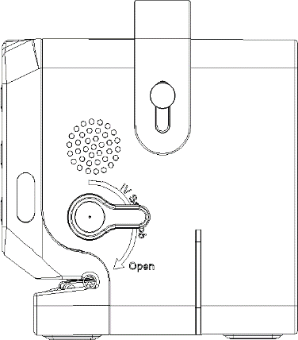
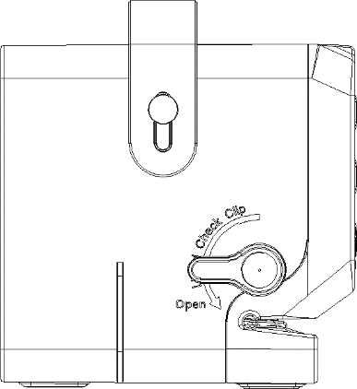
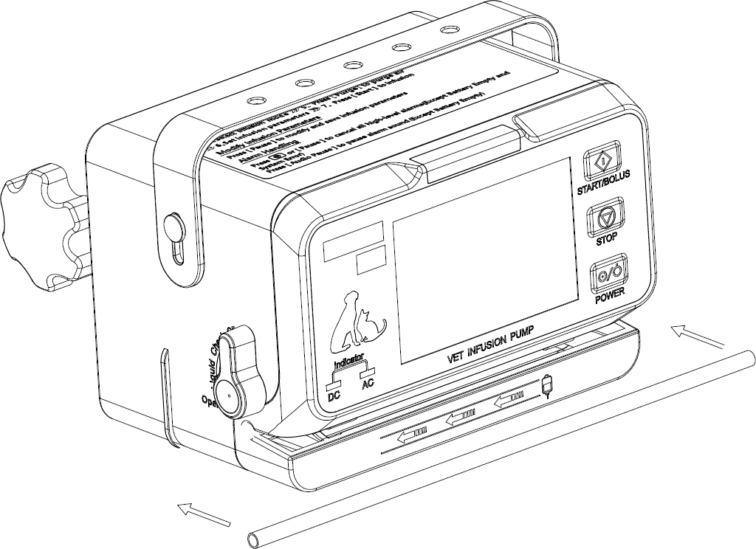

NOTE
- Please ensure the tube fill liquid fully before install IV set.
- The system will directly enter [Select Brand] if the infusion pump was installed an infusin set.
Install the infusion set as follows:
1. Rotate the IV Set Knob backward 90° to open.
2. Rotate the Liquid Check Clip backward 90° to open.
3. Straighten the IV set and horizontally place into the tube slot, and move back and forth in the tube slot several times to ensure that the IV set installation is straight and correct.

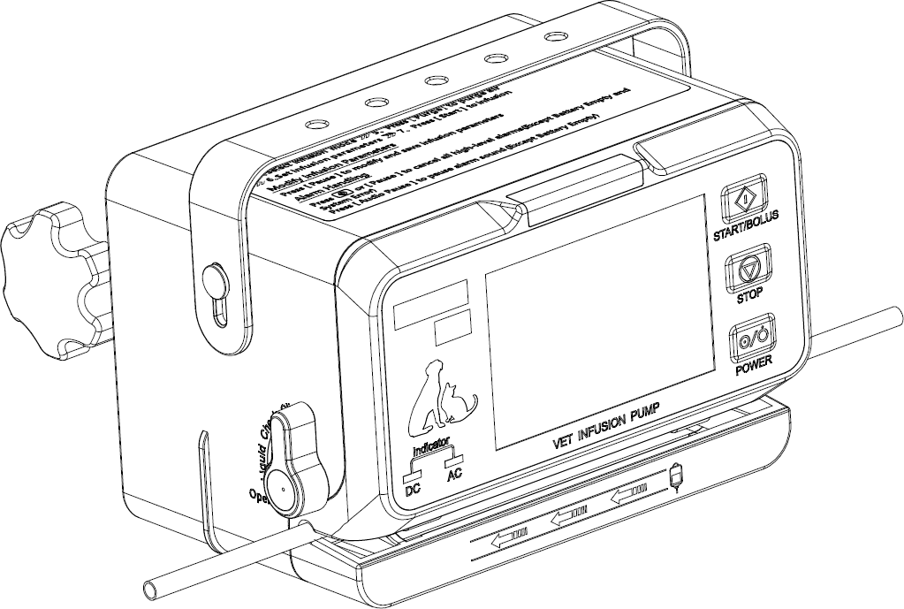
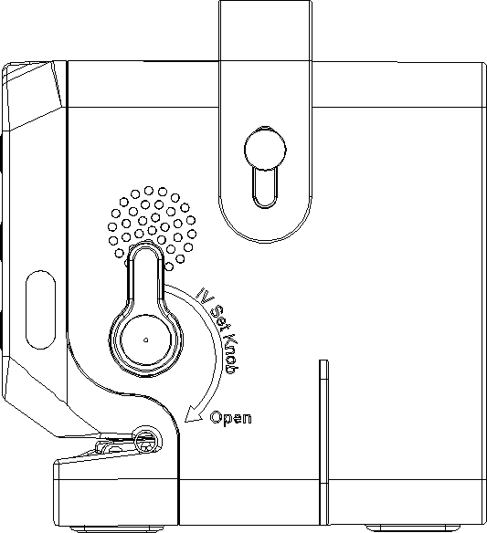

4. Rotate the IV Set Knob forward to
close position, the [Select Brand] interface will pop up, indicating that the tube is installed correctly.
5. Install IV set completely, if the [Select Brand] interface will not pop up, the tube needs to be re-installed.
WARNING

- The infusion set should be firmly loaded into the slot, and not jutting on the outside of the slot.
- Before using this infusion pump, the infusion pump, infusion set and other accessories should be loaded correctly.
- This device can normally use the recommended infusion set, if the non-recommended
infusion set is used, the company will not be responsible for the accuracy and alarm function of the device.

Replace the IV Set

Please follow the steps below to replace the infusion set:

      - To prevent animal injury due to free flow, before replace the infusion set or extruded tube, please shut down the Robert clip (or flow rate regulator). During infusion, press

or the [Pause] to stop the pump.

      - Turn the IV Set Knob and Liquid Check Clip backward to 90° to open, and take out the installed IV set.

      - Please refer to 4.2.2 Install the IV Set to reinstall the infusion set.

Replace the Infusion Bottle (bag)

Follow the steps below to replace the infusion bottle (bag):

      - To prevent animal injury due to free flow, before changing the infusion bottle (bag),

please shutdown the Robert clip (or flow rate regulator). During infusion, press [Pause] to stop the pump.
      - Take out the loaded infusion bottle (bag), and reload it.

Select Infusion Set Brand
The [Select Brand] interface will pop up automatically after the power-on self-test and the IV set was installed correctly, then you can select the brand of the IV set and press [OK] to confirm.
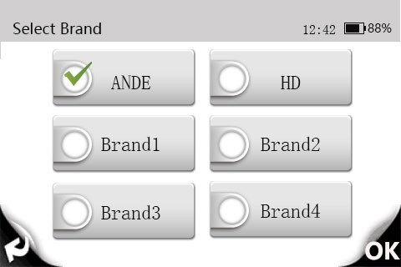

WARNING
- ANDE and HD were installed brands of infusion set in the pump. This pump can only use the recommended infusion sets. If a non-recommended infusion set is used, the company will not be responsible for the accuracy and alarm function of the equipment.
- This product can only use high elastic tube, if the operator is not sure whether the infusion set is a high elastic tube, please contact our company and we will provide a guide.

CAUTION
- Please confirm that the current selected brand is the same as the brand actually used, otherwise its accuracy cannot be guaranteed.

Select Infusion Mode
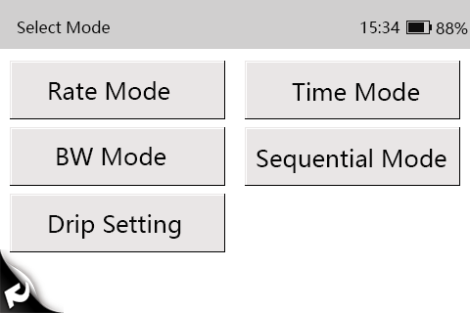
Select the infusion mode on the [Main Menu] interface, the operator can click [Select mode] for Model VP50, please refer to Chapter 5 Infusion Mode for the details introduction of each infusion mode.

VP50 Select Mode Menu

Purge
During infusion, the operator should prevent air bubbles from entering the blood with the liquid drug, which may form an aeroembolism and put animals in serious dangers. Therefore, air bubbles in the infusion tube should be eliminated before the infusion.
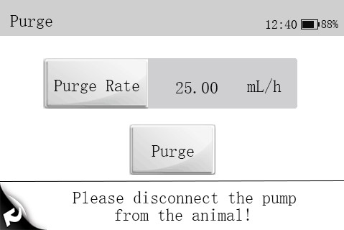
On the infusion mode interface, click [Purge] to enter the [Purge] interface, set the [Purge Rate], and press [Purge], will purge air at the set rate, and press [Pause], the Purge air is completed.

WARNING
- Please disconnect the pump from animal before purge air. Otherwise, the animal will be in serious danger！
- The default purge rate when venting is 800mL/h.
- The cumulative Purge volume will not calculate total cumulative volume.

NOTE
- [Air in Line] alarm will not be triggered during purge.

Set Infusion Parameters
The operator can set the infusion parameters under the [Rate Mode], Click [Rate] to set the infusion rate, click [ok] to confirm.
Click [VTBI] to set the VTBI, click [ok] to confirm.

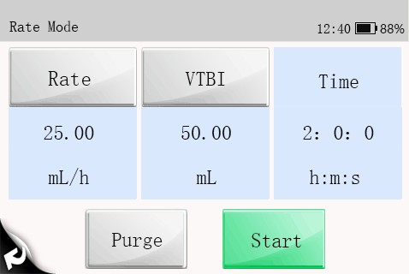

NOTE
- Please noted the Rate range is 0.1mL/h~1200.00mL/h（VP50 is 0.1mL/h~2000.00mL/h）, don’t exceed this rate range.
- Please noted the VTBI maximum is 0.1~ 9999.99mL, don’t exceed this rate range.

Infusion

Press or [Start] control to start infusion after correctly install the IV set and connect the animal. The faster the black arrow moves, the faster the infusion rate.

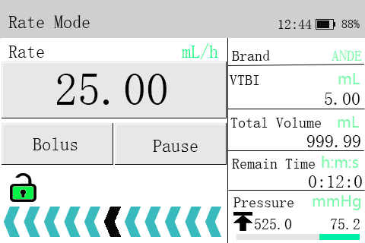

WARNING
- Operators should inspect and confirm whether the parameter settings are correct before infusion.
- If there is a liquid drug or residue on the ultrasonic sensor or the nearby tube surface, the operator should completely clean the area before infusion.
- Operators should regularly monitor the connection between the infusion set, pump and animal, and infuse according to the method mentioned in the manual.

NOT
- When in running status, if there is no operation in other interface over 15 seconds, it will return to the running screen automatically.

Infusion Pause

To press or the [Pause] control to stop infusion in running process.

BOLUS
To press [Bolus] control under infusion process, enter the [Bolus] interface. There are two ways to start the bolus:

- Manual Bolus: Set [Bolus Rate], press and hold to manual bolus, and release to return to the original rate.
- Auto Bolus: Set [Bolus Rate], [Bolus VTBI], press [Auto Bolus] to auto bolus.

NOTE
- The default rate in Bolus is 800mL/h.
- If there is no operation within 15 seconds in the Bolus setting interface, the interface will be automatically exited.
- During Bolus, 【Time Near End】Alarm will no trigger.
- Animal's clinical condition and working condition of the infusion pump must be monitored carefully.

Change the Rate during Operation
Directly press [Rate number] to enter the [Rate Value Editing] interface for setting the rate, and press [OK] again
to start the infusion at the new set rate.

Infusion Completed
The [Time Near End] alarm will be triggered when the remaining time of the infusion reaches the [Time Near End] set by the operator. If no action is taken, the alarm will continue until the infusion is completed, and it will switch to the [VTBI Completed] alarm after infusion finished. Please refer to 6.7 Time Near End for setting [Time Near End].
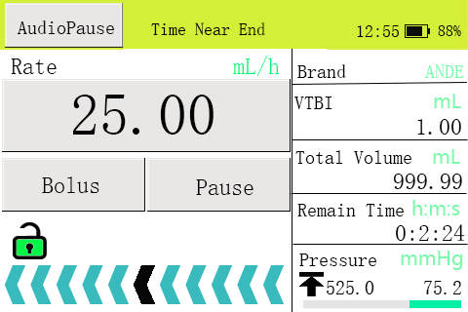
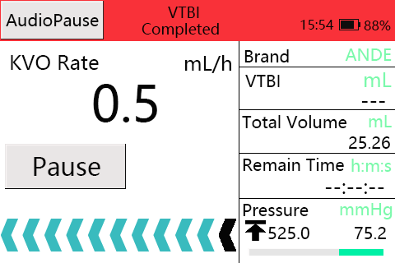

When the infusion is completed and auto enter the [KVO] mode, and KVO mode will finished within 30 minutes. The infusion will stop automatically and trigger [KVO Finished] after the end of KVO. See 6.1 KVO setting the KVO rate.

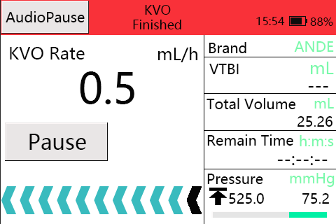

Standby

Press in non-running state will enter the [Shutdown Selection] interface, click the [Standby] control to setting the standby time. It can not Standby when in the high level alarm status.
It will be display [Standby Time Expired] after completed, press [] control to exit.

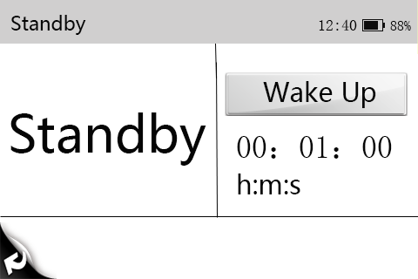
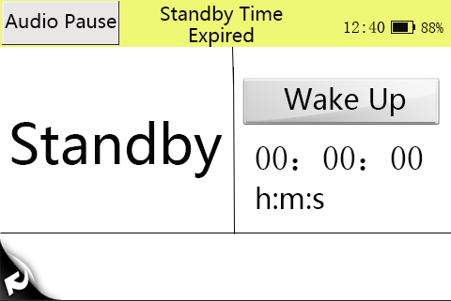

Shutdown
Please refer to the following steps to turn off the infusion pump:
      - Disconnect the animal;
      - Remove the infusion set;

      - Press enter the [Shutdown Selection] interface and click the [Shutdown] control to shutdown the infusion pump.

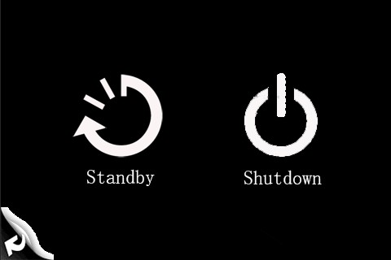

NOTE
- When power off normally, the current operating data and saved data will be autosaved.

Chapter 5 Infusion Mode

Rate Mode (VP50)

Mode | Parameters | Parameter Range
Rate Mode | Rate | Model VP50: 0.1-2000mL/h or 1-(400 x drip/60) drip/min
Rate Mode | VTBI | 0.1-9999.99mL
Rate Mode | Time | 00:00:01-99:59:59 h:m:s
Please refer to 5.5 Drip Setting for the settings of the unit of “drip/min”.

Time Mode (Model VP50)

Mode | Parameters | parameter range
Time Mode | Time | 00:00:01-99:59:59 h:m:s
Time Mode | VTBI | 0.1-9999.99mL
Time Mode | Rate | Same as Rate Mode

Body Weight Mode (Model VP50)

Mode | Parameters | parameter range
Body Weight Mode | Weight | 0.1～300.0kg
Body Weight Mode | Drug amt. | 0.1～999.9
Body Weight Mode | Drug amt. unit | Ng,μg, mg, g
Body Weight Mode | Volume | 0.1～9999.99mL

 | Dose Rate | 0.01～999.99
 | Dose Rate Unit | Ng/kg/min, ng/kg/h, ug/kg/min, ug/kg/h, mg/kg/min,  mg/kg/h, g/kg/min, g/kg/h
 | VTBI | 0.1～9999.99mL
 | Rate | Same as Rate Mode
NOTE：
[Rate] will be automatically calculated according to the formula（Dose Rate x Weight）/（Drug amt. / Volume）

Sequential Mode (Model VP50)
Several different sequences (parameter group) can be set in Sequential Mode, and the infusion pump infuses according to the set infusion sequence.
5 sequences can be set in this mode. The rate of the current sequence can be changed during the operation process. In Sequential Mode, the VTBI, Rate, and Time are settable and the ranges of the set values are taken to be the same with Rate Mode.
Σ: A sign denotes the total VTBI and the total time of all sequences.

NOTE
- If only set [Rate] or [VTBI] for a sequence, the sequence is invalid.
- If there is invalid sequence between sequences, the infusion can not be started.

Drip Setting (Model VP50)
On infusion parameters setting interface of Rate Mode, “mL/h” and “drip /min” can be switched. If [drip/min] →[Off] is selected, “mL/h” and “drip /min” can not be switched.
    - Select [Main Menu] → [Infusion Mode] → [Drip setting].
    - Select [drip/min] →[On], and set the “Drip”.

  - KVO

Chapter 6 General

KVO (Keep Vein Open) means to keep the vein open, during which the infusion pump continues infusion at a very low rate after finished the infusion in order to prevent blood backflow or vascular occlusion.
    - Select [Main Menu] → [General] → [KVO Rate].
    - Select [KVO Rate]: 0.1～5.0mL/h is adjustable.

Occlusion Pressure
Occlusion pressure is adjustable, which can meet the requirements for occlusion pressure of different animals during infusion. Pressure in the infusion tube can be measured by the built-in pressure sensor, pressure can be calculated by the internal CPU, which is compared with the preset occlusion alarm threshold. [Downstream Occlusion] alarm will be triggered if the pressure exceeds the threshold.

Select Occlusion Pressure
      - Select [Main Menu] → [General] → [Occlusion Pressure]:
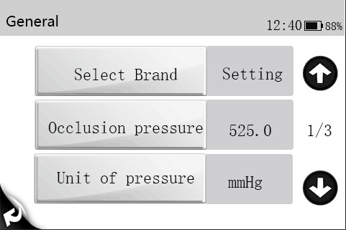
      - Select [Occlusion Pressure]: 3 Options occlusion pressure: 300mmHg / 525mmHg / 900mmHg, it is recommended to select suitable occlusion pressure according to actual requirements.

CAUTION
- If the animal experiences discomfort at a higher occlusion pressure, monitor the animal 's physical conditions under the higher occlusion pressure closely, and take measures instantly if any abnormal condition occurs.
- When the infusion set with ultrafilter at a lower occlusion pressure, the [Downstream Occlusion] alarm might be triggered at high rate due to resistence generated from liquid flow of ultrafilter. Select a higher occlusion pressure or lower rate to cancel alarm.

Set Unit of Pressure
      - Select [Main Menu] → [General] → [Unit of Pressure].
      - Select [Unit of Pressure]: mmHg, kPa, bar, psi for you choice and automatic conversion.

CAUTION
- Carefully confirm the edit when changing the current pressure unit.

Dynamic Pressure Detection (DPS)
During the infusion, the bottom right corner of screen will display real-time pressure change for check the tube occlusion at an earlier time and to prevent the occurrence of further complications.
The pressure icon indicates the pressure status as below:
- Green progress bar means the current pressure value is far from the blocking threshold
- Yellow progress bar means that the current pressure value is close to the blocking threshold
- Red progress bar means that the current pressure value exceeds the blocking threshold

NOTE
- When occlusion occures in the infusion set between the device and the animal, or occlusion pressure reaches the threshold value. The occlusion alarm will trigger, and the screen will display “Downstream occlusion”.

Automatic Pressure Release (Anti-Bolus)
When occlusion occurs, infusion will stop and the [Downstream occlusion] alarm will be triggered. After the alarm is triggered, the motor is reversed, and the cannula pressure is then released. This prevents an additional aggressive dose to the animal after the occlusion is eliminated.

Bubble Size
The smaller bubbles will be detected when select a lower level bubble size.
    - Select [Main Menu] → [General] → [Bubble Size].
    - Select [Bubble Size], 5 bubble sizes for choice: 50μl/100μl /250μl/500μl/800μl. It is recommending to select the suitable bubble size according to actual requirements.

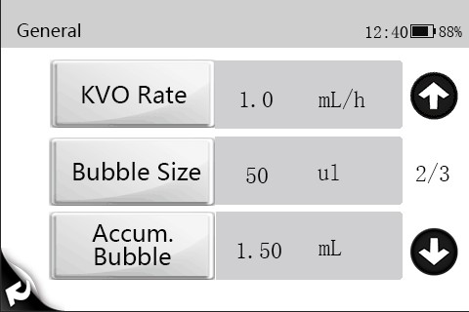

CAUTION
- If the animal experiences discomfort or danger at a higher air bubble filter level, monitor the animals 's physical conditions and select the actual needed level. Measures should be taken instantly if any abnormal condition occurs.

Cumulative Bubbles
    - Select [Main Menu] → [General] → [Accum. Bubble].
    - Select [Accum.Bubble]: 0.1～4.0mL/h is adjustable.

Key Lock Function
Automatic and manual lock:
- Automatic lock:
    - Select [Main Menu] → [General] → [Autolock Time];
    - Select [Autolock Time]: 1～5min (increment 1min).
The auto locking function will turn off if no any operation in the keypad within the set key lock time, and choose [√] or delete, it means to open or off the automatic locking function.
- Manual lock: Click  icon 1 second that the keypad and touch screen will be locking.
- Long press and hold icon 3 seconds to unlock, and auto unlocked when the high-level alarm occurs.

Reminder Function
    - Select [Main Menu] → [General] → [Reminder Time].
    - Select [Reminder Time]: 1～5min (increment 1min).
    - The alarm will be trigger if no any operation within setting time, and remind the

operator to next operation, choose [√] or delete to open or close.

Time Near End
    - Select [Main Menu] → [General] → [Time Near End].
    - Select [Time Near End]: 1～30min (increment 1min). when the remainder time reaches the time near end, the [Time Near End] alarm will be trigger. choose [√] or delete to open or close.

Infusion IV set Brands
This infusion pump has been inserted different infusion set brands for operator choice, and the operator can be self-defined IV set brand with correct calibration methods or follow actual situations.
    - Select [Main Menu] → [General] → [Select Brand].
    - choose [√] to set IV set brand.

List of recommended infusion sets
Serial  Number | IV Set Brand | Specifications
1 | ANDE | Disposable IV set with needle
2 | HD | Disposable IV set with needle

CAUTION
- It is recommended that infusion pump is used with high elastic tube. If you are not sure whether the tube is high elastic tube, please contact us for a guide.

Cumulative Amount Reset
Select [Main Menu] → [Total Volume] → [Cleaning].

Chapter 7 System

Sound Adjustment
    - Select [Main Menu] → [System] → [Sound].
    - Select [Sound]: 1～8, 1 is the lowest sound; 8 is the highest sound.

Adjust Screen Brightness
    - Select [Main Menu] → [System] → [Brightness].
    - Select [Brightness]: 1～8, 8 is the brightest, 1 is the darkest. When running on battery power, you can set a lower brightness to save battery power.

Bed Number Setting
    - Select [Main Menu] → [System] → [Bed Number].
    - Select [Bed Number]: 1-999.

Set Date and Time
    - Select [Main Menu] → [System] → [Date and Time].
    - Set [System Time] and [System Date].
    - Select [Time Format]: [24 H].
    - Select [Date Format]: [yyyy-mm-dd], [mm-dd-yyyy] or [dd-mm-yyyy].

NOTE
- Please check the system date and time to keep accurate records in the History function.
- After changing the time format or date format, the record will update new format automatically.

Language Setting
    - Select [Main Menu] → [System] → [Language].
    - In the [Language] menu, select [Language] as required.

History Record
Infusion data will store 2000 records above in the [History Record]. It will be removed previous data if the storage area is full.
    - Select [Main Menu] →[System] → [History Record].
    - Select [History Record]: Each page can display 5 records, select ()or(), turn pages.

Chapter 8 Alarm
The alarm is used in order to alert the medical staff by means of sound and light when abnormal situations occur during the infusion procedure which can lead to infusion changes or when the infusion of the animal cannot continue due to the unexpected breakdown or pause/delay of the infusion pump.

WARNING
- It is potentially hazardous to use the same or similar equipment with different alarm presets within the same area.
- Responsible organization shall evaluate the risks before selecting other alarm sound, for the operator may get used to the previous alarm sound, operators may not perceive the alarm in a timely manner due to new alarm sound.

Alarm Level
According to the severity scale of the alarm, the alarms of the infusion pump can be classified to high level alarms, medium level alarms and low level alarms.

Alarm Type
When an alarm occurs, the pump indicates it to you through visual or audible alarm indications. For more information, see the following table:
    - Light alarm
    - Sound alarm
    - Alarm information
Among the light alarm and the sound alarm and the alarm information will distinguish alarm levels in different ways.

Alarm  Level | Color of  Alarm Light | Audible Alarm  Frequency | Flashing Light  Frequency | Light/No-Light  Ratio
High Level  Alarm | Red | 10 seconds | 1.4～2.8Hz | 20%~60%
Mid Level  Alarm | Yellow | 15 seconds | 0.4～0.8Hz | 20%~60%
Low level  Alarm | Yellow | 20 seconds | Steady | 100%

Multi-Level Alarm Rules
When several alarms occur simultaneously, the alarms proceed according to the following rules:
      - When several alarms at different levels occur, the visible alarms and audible alarms are consistent with the highest level alarms.
      - When several alarms at different levels occur, only the highest level alarm is displayed, and after it is cancelled, the lower level alarm will then be displayed.
      - When several alarms at the same level occur, the alarm information will be demonstrated in an alternate manner.
The title bar of the infusion pump screen will display the corresponding alarm information during the alarm blast, to see more details in 8.5 Alarm Information.

NOTE
- Infusion pump alarm delays less than 5 seconds.

Alarm Handling Rules
Under normal working conditions, when an alarm occurs, all the alarm types of the infusion pump will alert according to their respective alarm levels. In addition, the operator can pause the alarm sound according to demands.
    - For high level (except No Battery) and medium and low level alarms, press [Audio Pause] pause alarm sound for 2 minutes. When the alarm pause time expires, the

alarm tone will sound. Press to cancel high level alarms (except No Battery and System Error).

NOTE
- [No Battery] alarm sound is unable to be paused.


Alarm Countermeasures

WARNING
- When an alarm is triggered, the animal’s condition should be checked first and operation should only be allowed to proceed after the reason for the triggering of the alarm is ruled out.

When an alarm is triggered, please refer to the following steps to check:
- Check the animal;

- Check the alarm type and the parameters;
- Check the reason for the alarm;
- Eliminate the reason for the alarm;
- Check whether the alarm was cleared.

NOTE
- For the specific handling measures of each alarm, please refer to 8.5 Alarm Information.
- The operator position shall be the normal operating position of the infusion pump (0.5m). Otherwise, operators might identify alarm mistakenly.
- The buzzer alarm will be triggered continue 3 minutes in case of no power supply or the battery is removed and abnormal.

Alarm Information
This chapter presents the alarm information of the pump. Prompt information for operation guidance will not be presented in this chapter.
The table shows the appropriate solutions for each information related to alarm triggering. If the problem still exists after operating according to the solutions, please contact the company.

Alarm information | Alarm Level | Reason | Countermeasure
[Downstream Occlusion] (VP50) | High | The line between the animal and the equipment is over pressure due to:  1, the infusion set road is knotted;  2, Use smaller gauge needles at high flow rates;  3, The blocking alarm level is  too low. | Check the pressing status of the line.  Check the occlusion of each interface.  Check if the occlusion pressure setting is reasonable.
[Upstream Occlusion] (VP50) | High | When the pump is infusing, the alarm is triggered due to an occlusion in the infusion tube between liquid source and equipment. Infusion is stopped after the alarm is  triggered. | Press to cancel alarm, check and eliminate the source of the alarm.
[No Battery] (VP50) | High | No battery is high alarm with Red color that mean the battery only can run 3  mins. | Connect the AC power supply to remove the alarm.

Alarm information | Alarm Level | Reason | Countermeasure
[VTBI Completed] (VP50) | High | Infusion volume delivered reaches the preset VTBI. | Press to remove alarm.
[KVO Finished]  (VP50) | High | KVO infusion reaches to 30 minutes. | Press to remove alarm.
[Air in Line] (VP50) | High | During infusion, the size of a single air bubble reaches the preset threshold for Air detection or air bubbles accumulated reaches the preset threshold for  Accumulate air. | Press to remove alarm and stop the infusion firstly, turn the IV Set Knob to open the tubesheet, and remove air from the tube.  Check if the bubble size setting is  reasonable.
[System Error]  (VP50) | High | Abnormal motor operation,  data communication error, sensor failure, etc. | This alarm cannot be removed,  and you need to stop using it, please contact our company.
[No Infusion Tube]  (VP50) | High | During the operation of the infusion pump, the infusion set falls off or infusion pump  tubesheet opened. | Press to remove alarm.
[Standby Time Expired] (VP50) | Medium | Pump is under standby mode and standby time was completed. | Press to remove alarm and exit standby.
[Reminder] (VP50) | Low | No operation within Reminder Time. | Operate the pump to remove the alarm.
[Low Battery] (VP50) | Low | Low battery is low alarm with yellow color that mean the battery can run ≥ 30  mins. | The alarm will remove after connecting the AC power.
[No Battery Inserted] (VP50) | Low | No battery inserted is low alarm with yellow color that mean the pump without  battery. | This battery is built-in the pump normally.
[No AC Power] (VP50) | Low | No AC Power is low alarm with yellow color that mean the pump only use battery  power( DC). | The alarm will remove after connecting the AC power.

Alarm information | Alarm Level | Reason | Countermeasure
[Time Near End] (VP50) | Low | Infusion remaining time reaches the setting value of [Time Near End]. | Alarm will not be removed automatically until the infusion is completed, and then switch to [VTBI Completed] alarm.  Press to stop infusion and remove alarm.

Note
- All alarm sounds can be paused by pressing [Audio Pause] , except for the circumstance of [No Battery].

Chapter 9 Battery

WARNING
- The battery can not be disassembled. The battery should be changed by maintenance staff designated by the company only. Changing the battery incorrectly or changing battery by personnel who has not received suitable training may cause such danger as overtemperature, fire or explode.
- Use only manufacturer-specified battery for this device. Use of a different battery may cause such danger as overtemperature, fire or explode.
- Do not touch the battery charging terminal and animal at same time to prevent animal leakage current from exceeding the requirements specified by the standard.
The infusion pump is configured with rechargeable Lithium batteries to ensure that
the infusion pump can be used normally under the condition of the animal's migration within the hospital or during the circumstance of a power failure. When the infusion pump switches to the AC power, the battery can be charged regardless of whether the infusion pump is on or off. The battery is chargeable only within the infusion pump. During charge, the battery icon in the upper-right corner of the screen floats up and down. If the battery icon stops floating and is completely filled, it indicates that the battery is fully charged. Under the condition of a sudden power failure, the pump will automatically use the battery to provide power as a backup.
The battery icon on the screen indicates the status of the battery:

A battery is installed in the battery slot of the infusion pump, and the
black filled area indicates the battery level.
The battery is low and needs to be charged.
The battery is exhausted and needs to be charged immediately.
There are no batteries installed in the infusion pump.
The infusion pump is charging.

The battery power supply can only last for a period of time. When the voltage of the battery is too low, the [No Battery] alarm will be triggered, and the alarm light will flash red. At this time, the infusion pump should be immediately connected to the AC power supply for charging.

NOTE
- Please remove the batteries before conveying or when out of use for a long time.
- When the built-in battery and external power encounter failure, the display will off, a high level alarm will be triggered, the buzzer will sound out and the red alarm light will continuously flash.

Check Battery Performance
The performance of the battery may decrease over time. Please follow the steps below when checking the battery:
    - Disconnect the pump from the animal and stop the infusion.
    - Switch the infusion pump on the AC power and charge the battery incessantly for 16 hours above.
    - Disconnect the AC power and use the battery to charge the infusion pump until the infusion pump is closed.
    - The length of the battery’s lifetime reflects the performance of the battery.

NOTE
- The lifespan of the battery depends on the used frequently and time, battery capacity decreases with increase in charging and discharging times. If the use of battery is improper, its lifespan shall be shortened or in failure status.
- Please connect to the AC power and re-charge battery if [No Battery] alarm is triggered.
- If battery will not be used in a long time, we recommend keeping the battery in a fully charged state and charging the battery every six months.
- The length of the battery's lifetime depends on the device configuration and operation, for example: Under the condition of the power supply by the battery, frequent infusion at a high rate will also shorten the length of the battery's lifetime.

Install the Battery
Replace the battery:
    - It is suggested to turn off the infusion pump power source, and disconnect the power source line.
    - Tilt or lay the infusion pump down.
    - Open the battery cover.
    - Remove the old battery, install the new one into the battery slot and insert the battery lock.
    - Close the battery door and return the infusion pump to its upright position.

Battery Recycling
If there is any obvious damage to the battery or to the battery capacity exhausts, it should be replaced and recycled appropriately. Please follow the applicable laws on recycling.
WARNING
- The battery must not be disassembled, burned or short-circuited.Burning, exploding or leaking battery can cause personal injury.

Chapter 10 Preservation and Sanitation
The pump must be cleaned or disinfected using the materials and methods listed in this section. The manufacturer will not be responsible for any damage or accident caused by cleaning and disinfection using other materials and methods.
The manufacturer shall not be held responsible for the efficacy of the following chemicals or methods for infection control. Please contact your hospital's infection prevention department or epidemiology specialists for advice on infection control practices.

Description
Please make sure that your device and other fittings are clean without dust. In order to prevent any damage to the device, please abide by the following rules:
- Dilute all cleaning agents and disinfectants in accordance with the manufacturer’s instructions, or use as low a concentration as possible.
- Do not immerse or submerge the device in liquid.
- Do not pour liquid on the device or accessories.
- Avoid liquid from entering the pump body.
- Do not use abrasive materials (such as steel wool or silver polishes), or any strong solvent (such as acetone or any detergent containing acetone).

WARNING
- Turn off the pump and disconnect the AC power source line from the socket before cleaning. Do not clean and disinfect the device, export history record and perform
other operations when animals are using the pump.

Cleaning
The pump should be cleaned regularly. If operating in dirty or sandy areas, cleaning should be more frequent. Before cleaning, please consult or refer to the hospital's specific regulations concerning medical device cleaning.
The recommended detergents include: Hydrogen peroxide (3%), Ethanol (70%), Isopropanol (70%).
To clean your equipment, follow these rules:
    - Turn off the pump and disconnect the AC power source line.
    - Wipe the display screen after soft cotton balls absorb an appropriate amount of detergent.
    - Use a piece of soft cloth which absorbs a modest amount of cleaning agent to wipe the surface of the device.
    - When necessary, use a piece of cloth to wipe off any excess cleaning agents.
    - Place the pump in a cool and ventilated environment to dry.

Disinfection

The operation of disinfection may cause certain damage to the pump. You are recommended to disinfect only when it is necessary in your desired maintenance plan. Clean the equipment before disinfection.
The recommended disinfectants include: Ethanol (70%), Isopropanol (70%), glutaraldehyde-type 2% liquid disinfectant.

CAUTION
- Never use EtO or formaldehyde for disinfection.
- Do not conduct high pressure or high temperature disinfection for the pump and its accessories.

Chapter 11 Maintenance

WARNING
- To avoid electric shock, stop using the device if you find its housing has signs of broken. Contact the service personnel for help in that case.
- The hospital or medical facility using this pump must set up a comprehensive maintenance plan. Failure to do so may result in equipment failure or other unexpected consequences, and may even jeopardize personal safety.
- All safety inspections or maintenance work involving the disassembly of the device must be conducted by professional maintenance personnel. Actions by unqualified persons may result in device failure and may even jeopardize personal safety.
- Please contact the company immediately if you encounter problems with the device (such as the warning label off).
- The device and accessories shall not be served or maintained while in use with a animal.

Inspection
The pump needs a full inspection under follow conditions: first time use, continuous use 6-12 months, and maintenance or upgrades, to ensure that it is operated and functioned normally. The inspection criteria are:
    - The environment and power supply meet requirements.
    - The equipment and accessories have no mechanical damage.
    - The power cord is not damaged and has sufficient electrical insulation.
    - Accessories used with the pump are correct.
    - The alarm system functions correctly.
    - Battery performance.
    - Self-checking and pump functions are normal.
If there are any forms of damage or abnormal circumstances, do not use the pump and contact the company immediately.

Maintenance Plan

The following tasks must be conducted by professional maintenance personnel approved by the company. Please contact the company if the following maintenance are needed. Must clean and disinfect the device before the test or maintenance.

Inspection/Maintenance Items | Frequency
Perform a safety inspection according to the IEC60601-1 standard. | Once every two years. Perform after the board is changed or the pump is  accidentally dropped.
Preventive maintenance (refers to the Maintenance Manual for pressure calibration, sensor calibration, and pump inspection). | Once every two years, or when you suspect the occlusion alarm is abnormal, the flow volume is inaccurate, or the  infusion set is incorrectly identified.

View Information
Select [Main Menu] → [System] → [History Record], you can check the infusion parameters, alarm information, operation information and other information.
Select [Main Menu] → [System] → [Version], you can check the Software Version, Brand Library Version and other Versions.

Restore Factory Setting
- Select [Main Menu] → [Maintenance] → Enter user maintenance password →
[Restore Factory Default].
- The interface prompts [Restore factory default or not?].
- Press [Confirm] to confirm and restore the factory default values of all parameters except system maintenance; Press [Return] to cancel and exit the interface.

Safe Disposal and Recycling
Please contact the company for related information about safe disposal and recycling.

WARNING
- Use the accessories specified in this chapter only. Other accessories may cause damage to this infusion pump, or cannot reach the specification in this manual.
- Please do not replace an accessory if its package or itself is damaged.

Materials | PN
Lithium Battery | 10-00001-00
Power Cord | 13-00001-00
Pole Clamp | 60-00001-00

NOTE
- This Operator’s Manual describes the most complete functional configuration of the system. The device you are using may not have some of the settings or functions described herein.

Safety Specifications

Product Classification

Safety Classification
Components | Host
Type of Protection  Against Electric Shock | Class I
Degree of  Protection Against Electrical Shock | Type CF defibrillation proof
Ingress Protection | IP34
Degree of safety of application in the presence of flammable anesthetic mixture with air or with oxygen or nitrous  oxide | The equipment is not suitable for use in the presence of a flammable anesthetic mixture with air or with oxygen or nitrous oxide.
Mode of Operation | Continuous
Mobile Level | Portable

NOTE:
      - CF: Type CF applied parts, can be directly used in the heart.
      - IP34: Protected against solid foreign objects with a diameter no less than 2.5mm, and protected against spraying water.
      - Not suitable: The device is not suitable for use in environments containing flammable anesthetic gases mixed with air, oxygen or nitrous oxide.
      - Portable devices: Can be moved from one place to another by one or more persons or by other means when the devices are in use or being used.

Working Environment
Temperature | 5 to 40ºC
Humidity | 15～95%, non-condensing
Atmospheric Pressure | 57～106kPa
Storage Environment
Temperature | -20~60ºC
Humidity | 10～95%, non-condensing
Atmospheric Pressure | 50～106kPa
Storage Conditions | Corrosive-free and ventilated indoors
AC Power Specifications
Input Voltage | 100-240V～
Frequency | 50/60Hz
Input Current | 0.8-0.3A
Fuse | Low breaking,T2AL 250V～
External DC Power Supply
Input Voltage | DC 13V-15V
Input Current | 2.3-1.5A

Physical Specifications

Part | Weight | Size | Remark
Host | Approx.  1.3kg | 165 x 103 x 100(mm) (L×H×W) | Included Battery

  - Hardware Specifications
    - Display

Display
Type | Colorful Touch TFT LCD
Dimensions  (diagonal) | 3.5 inches
Resolution | 480 x 320 pixel

Internal Battery
Number of Batteries | 1
Battery Type | Lithium Ion Battery
Shutdown Delay | The pump will be shutdown about 30 minutes start from trigger the alarm after the new battery is running low.
Rated Battery Voltage | 11.1VDC
Battery Capacity | 2900mAh
Power Supply Time | By factory default, continuously operate at a rate of 25mL/h, discharge for at least 9h using a fully charged new battery.
Charging | It will keep charging under operating state.

    - Host LED

Host LED
Alarm Indicator | 1 (two colors: red, yellow)
AC Power Indicator | 1 (green)
Battery Status  Indicator | 1 (green)

    - Auditory Indication

Speaker | Produce an alarm, the sound pressure is 55-73 dB(A) and key beep;  Support multi-level sound functions; The alarm sound meets the requirements of the IEC60601-1-8.

    - Interface

Power Supply | One AC power interface, one DC power interface.
Other Interfaces | TYPE-C interface

    - Signal Output

Auxiliary Output Interface
Standards  Compliant | Meets the requirements of the IEC 60601-1 standard for short-circuit  protection and leakage current.
Output Impedance | 50Ω

Specifications

Parameter | Specification
Infusion Set Standard | Infusion set used in conjunction with infusion pump should meet the requirements of ISO 8536-4:2019 Infusion equipment for medical use- Part 4: Infusion sets for single use, gravity feed, MOD.
Infusion Lines in the List | The diameter of the tube is Φ3.0-4.5mm, and the double wall thickness of the tube is 0.6-1.0mm.
Rate | Model VP50: 0.1-2000mL/h or 1-(400*Drip /60) drip/min
Minimum  increment of Rate | Model VP50: 0.01mL/h or 1 drip/min
Bolus Rate | Model VP50: 0.1-2000mL/h
Purge Rate | Model VP50: 0.1-2000mL/h
VTBI | 0.1~9999.99mL, the minimum increment is 0.01mL
Total Volume | 0.00～9999.99mL, the minimum increment is 0.01mL
Time | 00:01 -99:59:59 h:m:s
Standby time  range | 00:00:01-99:59:59 h:m:s
Select Mode | Model VP50: Rate Mode, Time Mode, Body Weight Mode, Sequential Mode
KVO rate | 0.1～5.0mL/h, the minimum increment is 0.1mL/h
Anti-bolus switch | On, Off
Occlusion Pressure | 3 Levels are adjustable, respectively 300 mmHg, 525 mmHg, 900 mmHg. The error is ±20% or ±113mmHg(15.1kpaF), whichever is larger.  Maximum occlusion pressure is about 1080mmHg.  Note 1: The detected pressure of the infusion system (infusion pump and infusion set) is affected by inner and outer diameter, material, elasticity of the infusion set and other factors. Therefore, infusion sets of different brand and model may differ in the detected pressure range.  Note 2: The above declared pressure is based on ANDE and HD infusion  sets, temperature of 20±2℃.
Unit of Pressure | mmHg, kPa, bar, psi
Bubble Size | 1~5 Levels, respectively are (50,100,250,500,800) μl Sensitivity of single air bubble is 20μl.  Note 1: The detected air detection of the infusion system (infusion pump and infusion set) is affected by inner and outer diameter, material,  elasticity of the infusion set and other factors. Therefore, infusion sets of

different brand and model may differ in the detected air detection. Note 2: The above declared pressure is based on ANDE and HD infusion
sets, temperature of 20±2℃.
Auto-lock Time | off, 1~5min, the minimum increment is 1min
Reminder Time | off, 1~5min, the minimum increment is 1min
Time Near End | off, 1~30min, the minimum increment is 1min
Bed Number | 1-999
Sound | 1~8
Brightness | 1~8
System Date and Time | System time: _ _ : _ _
System Date and Time | System Date: _ _ _ _-_ _-_ _
System Date and Time | Time format: 24 H
System Date and Time | Date format: yyyy-mm-dd, mm-dd-yyyy or dd-mm-yyyy
System Language | Chinese and English for choice
History Record | 2000 records above
Infusion Accuracy | Infusion accuracy ±5%  Note 1: The infusion accuracy of the infusion system (infusion pump and infusion set) is affected by inner and outer diameter, material, elasticity of the infusion set and other factors. Therefore, infusion sets of different brand and model may differ in the infusion accuracy.  Note 2: The above declared pressure is based on ANDE and HD infusion  sets, temperature of 20±2℃.
Alarm Information | See complete information in 8.5 Alarm Information
Dose of Single Fault | ≤1.5mL  Note: The above declared single fault is based on ANDE and HD infusion  sets at a rate of 25mL/h.
Status Indicators | Stop, Infusion, Bolus, KVO, Pause, Standby, Alarm, Purge.

This chapter lists some of the default factory settings for the infusion pump. The operator can not change the factory setting, but can restore the infusion pump to the default factory setting when needed.

Parameter Setting | Default Setting
Sound | 4
Volume | 0mL
Brightness | 4
KVO Rate | 0.5mL/h
Unit of Pressure | mmHg
Occlusion Pressure | 525mmHg
Anti-bolus switch | On
Bubble size | 100μl
Cumulative bubbles | 1.50mL
Autolock Time | Off
Reminder Time | 2 minutes
Time Near End | 3 minutes
Commonly used brands  (recommended brands) | ANDE
Bed Number | 1
Standby time range | 24:00:00
Night Mode | Off
System time | 00:00:00
System date | 2022-1-1
Time format | 24 H
Date format | dd-mm-yyyy

B-1

  - List of Units

Abbreviation | English
A | Ampere
Ah | Ampere hour
°C | Centigrade
cm | Centimeter
dB | Decibel
°F | Fahrenheit
g | Gram
hr | Hour
Hz | Gertz
inch | Inch
k | Kilo
kg | Kilogram
kPa | Kilopascal
l | Litre
lb | Pound
m | Meter
mg | Milligrams
min | Minute
mL | Milliliter
mm | Millimeters
mmHg | Millimeters of mercury
ms | Millisecond
mV | Millivolt
mW | Milliwatt
nm | Nanometer
s | Second
V | Volt
VA | Volt ampere
Ω | Ohm
µA | Microampere
µm | Micron
µV | Microvolt
W | Watt

  - Technical Alarm Message

Symbol | English
- | Minus
% | Percent
/ | Per; Divide; Or
~ | To
^ | Power
+ | Plus
= | Equal to
< | Less than
> | Greater than
≤ | Less than or equal to
≥ | Greater than or equal to
± | Plus or minus
× | Multiply
© | Copyright
  - List of Terms

Abbreviation | English Meaning
AC | Altenating current
Anti-Bolus | Anti-Bolus
BOLUS | Bolus
CCU (CICU) | Cardiac Intensive Care Unit
CE | Conformité Européenne
CPU | Central Processing Unit
DC | Direct current
DPS | Dynamic Pressure System
EMC | Electromagnetic compatibility
EMI | Eelectromagnetic interference
EEC | European Economic Community
EtO | C2H4O
ECU (EICU) | Emergency Intensive Care Unit
KVO | Keep vein open
ISO | International organization for Standardization
Led | Light emitting diode
RAM | Random access memory
ROM | Read-only memory
SN | Series Number
VTBI | Volume To Be Infused
TIVA | Total Intra Venous Anesthesia
ICU | Intensive Care Unit
ID | Identification

Abbreviation | English Meaning
IEC | International Electrotechnical  Commission
IEEE | Institute of Electrical and Electronic  Engineers
ISO | International organization for  standardization
IT | Injectate temperature
led | Light emitting diode
LVD | Low voltage directive
Max | Maximum
Min | Minimum
MDD | Medical Device Directive
N/A | Not applied
NICU | Newborn Intensive Care Unit
OR | Operating room
Paw | Airway pressure

  - List of Unit Conversion

Unit Symbol | Unit Conversion
kPa | 1kPa=7.5mmHg=0.145psi=0.01bar
psi | 1psi=51.724mmHg=6.897kPa=0.069bar
bar | 1bar=750mmHg=14.5psi=100kPa

D Toxic and Hazardous Substances or Elements

Part Name |  | Lead Pb | HG  Hg | Cad miu m  Cd | Hexaval ent chromiu m  Cr(VI) | Polybromin ated biphenyls  PBB | Polybrominat ed diphenyl ethers  PBDE
Machine shell | Front Shell | ○ | ○ | ○ | ○ | ○ | ○
Machine shell | Back Shell | ○ | ○ | ○ | ○ | ○ | ○
Machine shell | Button | ○ | ○ | ○ | ○ | ○ | ○
Machine shell | Veneer | ○ | ○ | ○ | ○ | ○ | ○
Machine shell | Stickers | ○ | ○ | ○ | ○ | ○ | ○
Display | Display | ○ | ○ | ○ | ○ | ○ | ○
Host | Host Hardware | ○ | ○ | ○ | ○ | ○ | ○
Host | Internal  Connection Line | ○ | ○ | ○ | ○ | ○ | ○
Host | PCBA | ○ | ○ | ○ | ○ | ○ | ○
Package | Carton (K=K  corrugated paper) | ○ | ○ | ○ | ○ | ○ | ○
Package | Foam (EPE) | ○ | ○ | ○ | ○ | ○ | ○
Package | Plastic bag (PE) | ○ | ○ | ○ | ○ | ○ | ○
Universal | Connector | ○ | ○ | ○ | ○ | ○ | ○
Universal | Power Cord | ○ | ○ | ○ | ○ | ○ | ○
Battery | Battery | ○ | ○ | ○ | ○ | ○ | ○
Appendix | Appendix | ○ | ○ | ○ | ○ | ○ | ○
Remark | - : Indicates that the content of this toxic and hazardous substance in all homogeneous materials of this part is below the limit requirement specified in SJ/T11363-2006.  ×: Indicates that the content of this toxic and hazardous substance in at least one  homogeneous material of the part exceeds the limit requirement specified in SJ/T11363-2006.

D-1

5 2 - 0 0 0 0 9 - 0 0
P/N: 52-00009-00 (1.0)

5 2 - 0 0 0 0 9 - 0 0
P/N: 52-00009-00 (1.0)

