SERIES CLASS B Steam Sterilizer Operation Manual

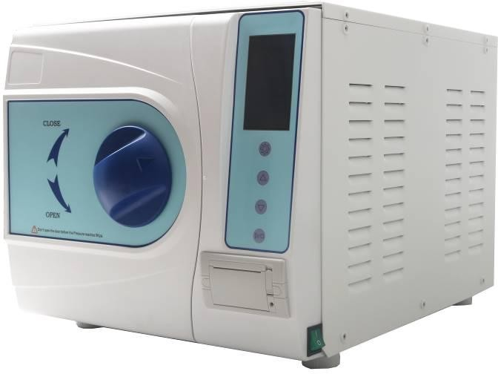

JS-PD-01 REV-A/0


Operation Documentation

Regulatory Requirement

This product complies with regulatory requirements of the following European Directive 93/42/EEC concerning medical devices.

This manual is a reference for the SERIES CLASS B. It applies to version of the R1.0 software for the SERIES CLASS B steam sterilizer.

Revision History

REV | ISSUE DATE | REASON FOR CHANGE
Rev-A | 2017.06.08 | First Issue

Page NUMBER | REVISION No. | Page NUMBER | REVISION No.
Title Page | Rev-A | Chapter 7 | Rev-A
Regulatory Requirement | Rev-A | Chapter 8 | Rev-A
Revision History | Rev-A | Chapter 9 | Rev-A
Chapter 1 | Rev-A | Chapter 10 | Rev-A
Chapter 2 | Rev-A | Appendix 1 | Rev-A
Chapter 3 | Rev-A | Appendix 2 | Rev-A
Chapter 4 | Rev-A | Appendix 3 | Rev-A
Chapter 5 | Rev-A | Appendix 4 | Rev-A
Chapter 6 | Rev-A | Appendix 5 | Rev-A

Please verify that you are using the latest revision of this document. Information pertaining to this document is maintained on manufactury. If you need to know the latest revision, please contact your distributor, sales representative, or our service dept.

Regulatory Requirements

Conformance Standards

The content of this instruction is fit for sterilizers.

Above sterilizer accord with the requirements of European Class B: 93/42/EEC

97/23/EC

EN 61010-1:2010

EN 61010-2-040: 2015

EN 13060:2014

EN 61326-1:2013

European Authorized Representative

Service&quality s.r.l. –ondapulsante

Address: vat 11043601001,Via degli olmetti 5b int A14, Formello (Rome),Italy Tel: +393939169243

email: magia_grandis@yahoo.it

This product complies with the regulatory requirement of the following:

- Council Directive 93/42/EEC concerning medical devices:
The CE label affixed to the product testifies compliance to the Directive. The location of the CE marking is shown in this manual.

Certifications

Manufactory is ISO 9001 and ISO 13485 certified.

Original Documentation

The original document was written in English.

Declaration of Conformity

Council Directive 93/42/EEC concerning medical devices:
The CE label affixed to the product testifies compliance to the Directive.
The location of the CE marking is shown in this manual. In this manual there are present the CE certification and the Conformity. Check appendixes.

Tabel of Content
Regulatory Requirement 1
Revision History 1
Regulatory Requirements 2
Tabel of Content 3
Chapter 1 Introduction 5
  - Attention 5
  - Indications for Use 5
  - Contraindication 5
Chapter 2 Safety 6
  - Explanation Symbol 6
  - General Recommendations–Safety 8
  - Safty Parts 9
  - Operation Risk 10
  - Protection Device 10
Chapter 3 Receiving And Installation 11
  - Check the Package 11
  - Unpacking the Accessories 11
  - Installation Enviroment 12
  - Set 12
  - Power Connection 13
Chapter 4 Description And Specification 14
  - Front View of the Sterilizer 14
  - Rear View of Sterilizer 15
  - Opened Vew of Sterilizer 15
  - Outside Size 17
  - Loading Size 17
  - Specification 17
  - Sterilization Cycle 19
Chapter 5 Panel And Functions 20
  - Controlling Panel 20
  - Menu 21
Chapter 6 Operation Process 23
  - Power On 23
  - Distilled Water Adding 23
  - Alarming If Used Water Reservoir Is Full 25
  - Selecting Sterilizing Program 25
  - Loading Instrument 25
  - Closing The Door 26
  - Starting A Working Cycle 28
  - End Of The Sterilization Working Cycle 29
  - Power Off 29
  - Abnormal Exiting 30
  - Sudden Power Off 30
Chapter 7 Essential Information 31
  - Please Ensure The Following 31
  - And Please Do Not 31
Chapter 8 Maintenance 32
  - Maintenance Schedule Chart 32
  - Daily Maintenance 32
  - Weekly Maintenance (More Often If Necessary) 33
  - Monthly Maintenance 34
  - Maintenance To Be Done As Required 35
Chapter 9 Servicing By The Approved Technician 36
Chapter 10 Transportation And Storage 37
  - Preparation Before Transportation And Storage 37
  - Draining 37
  - Conditions For Transportation And Storage 37
  - Package 37
Appendix 1 Instrument Which Need To Sterilize 38
Appendix 2 Error Code List 39
Appendix 3 Main Parts 40
Appendix 4 Electric And Hydraulic Drawings 41
Hydraulic Drawing 41
Electric Drawing 42
Appendix 5 The Standards Of Testing 43

Chapter 1 Introduction

Attention
- This manual contains necessary and sufficient information to operate the system safely, like optimal use, a safe and reliable operation, regular and correct servicing requirements.
- Read and understand all instructions in this manual before attempting to use the product.

- Keep this manual with the equipment at all times. Periodically review the procedures for operation and safety precautions.

Indications for Use
An apparatus for steriliaing packaged medical devices,e.g. surgical instruments,using steam as the sterilizing agent for the inactivation of micro-organisms.

The sterilization of all wrapped or non-wrapped, solid, hollow load products type A and porous products or concerning instrument.

This sterilizer applys for dental clinic, laboratory, operation room, emergency room, ophthalmology, gynecology and steam, cosmetic hospital and so on, which are used especially by doctors and professionals.

Contraindication

There is no any contraindication of this equipment.

Chapter 2 Safety

Explanation Symbol

Device Icon Description

 | “ATTENTION” – Consult accompanying documents” is intended to alert the user to refer to the operator manual or other instructions when complete information cannot be provided on the label.
 | It recommends attention to be paid to the high temperatures associated with the chamber, and the sterilizer steam draining from the cover when it is running.
 | “Protective Earth” indicates the protective earth (grounding) terminal.
 | “CAUTION” - Dangerous voltage” (the lightning flash with arrowhead) is used to indicate electric shock hazards.

Label Icon Description

 | Symbol for "SERIAL NUMBER" |  | Symbol for "MANUFACTURER"
 | Symbol for "CATALOGUE NUMBER" | 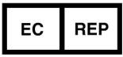 | Symbol for "AUTHORISED REPRESENTATIVE IN THE EUROPEAN  COMMUNITY
 | Symbol for "DATE OF MANUFACTURE" |  | Symbol for "CAUTION"

Manual Prompt

Note | Indicates that concerning information which easier or helpful in operation
Caution | Indicates that a potential hazard may exist which through inappropriate conditions or actions will or can cause:  - Minor injury  - Property damage.  - Damage to machine
Warning | Indicates that a specific hazard is known to exist which through inappropriate conditions or actions may cause:  - Severe personal injury  - Substantial property damage  - Deeply damage to machine

NOTE: Indicates precautions or recommendations that should be used in the operation.

General Recommendations–Safety
- The user is responsible for operation and servicing the sterilizer in accordance with the instructions listed in this manual.
- The sterilizer has not been designed for the sterilization of liquids.

- The sterilizer has not been designed to operate in the presence of gas or explosive vapors.
- The trays and the load will still be hot at the end of each cycle. Use the tray holder to remove each tray from the chamber.
- Do not open the door of the chamber when you are running the sterilization programs or seeing the “6KPa”.
- Do not put you hands or face on the cover of the water tank when the sterilizer is running.

- Do not remove the instruction plate or any label from the sterilizer.

- Do not pour water or any other liquid over the sterilizer.

- Do not fill the caustic liquid into the water tank.

- Do not fill the caustic matter in the chamber.

- Use only high quality distilled water.

- Unplug the mains lead before inspecting or servicing the machine.

- Only an approved technician using original spare parts can carry out repairs and maintenance.
- In case of transport, drain both water tanks completely, allow the sterilization chamber to cool down and preferably use the original packaging.
- The goods to be sterilized could be picked-up by special handle of getting plate when the temperature shows over 40℃.
- Picking-up the sterilizing plate should use the special handle provided by this sterilizer.

- During the transport, the 4 bottoms of sterilizer should be raised by two men in case of turning over.
- Notice! This product can’t be put on the place that is not easy to cut off power supply.

- Prohibit covering the cover of water tank when using.

Safty Parts

Temperature Protection
Part Name | Function
Temperature Protecter  (Steam Gernerator) | It will be broken circuit if the steam generator temperature is  too high.
Temperature Protecter  (Heating Ring) | It will be broken circuit if the heating ring temperature is too  high.

Electronic Protection
Part Name | Function
Double Fuse | It will be broken circuit if the connected power is too high or  unstable.
Electronic Filter | It will filter the electromagnetic interference during working

Mechanical Protection
Part Name | Function
Jiggle Swich | To ensure the door is closed completely for avoiding the risk of  sfafty
Tray removal tong | Defend to scald during take out the instrument after finish cycle

Control Part
Part Name | Function
Temperature Sensor  (Inside Chamber) | To measure temperature inside the chamber
Temperature Sensor  (Heating Ring) | To measure temperature of the heating ring
Temperature Sensor  (Steam Generator) | To measure temperature of the steam generator
Pressure Sensor | To measure pressure of the chamber
Control PCB | Control system for controling all the process of sterilization

CAUTION ANY ARBITRARY DISCHARGING, REVISING, OR CHANGING IN THE UNIT IS NOT ALLOWED BY UNAUTHORIZED PERSON OR UNPROFESSIONAL TECHNICIAN

Operation Risk
Please take attention on avoid operation risk during operation.

Scald risk

- Every time open the door after finish the cycle, please keep an appropriate distance, because the chamber still have rudimental steam with high temperature, avoid to be scalded.
- Every time open the door after finish cycle, please not touch the mian door and chamber, because of high temperature, and avoid to be scalded.

Pollution risk

Please clean the chamber after evey time use to avoid rudimetal contamination left inside chamber

Protection Device

Device Name | Function
Plastic or fabric glove | It is useful to operate during the load or take the instrument to  avoid scalding.

Chapter 3 Receiving And Installation

Check the Package
Please check package carfully when you receive the product, any damge of package maybe damge the product inside.

Unpacking the Accessories
Open the package and take the product out, remove the plastic bag then open the door to take all the accessories and check as followed:
No. | Part Name | Qty
1 | Tray holder | 1 piece
2 | Anodized aluminum trays | 3 sets
3 | Tray removal tong | 1 piece
4 | Draining tube | 1 piece
5 | Power supply cable | 1 piece
6 | Sealing ring | 1 piece
7 | Operation manual | 1 piece
8 | Fuse | 2 piece
9 | Measuring cup | 1 piece

Installation Environment
The sterilizer should be set in a place which at least has 10cm distance with each side (20cm of the top) as followed:

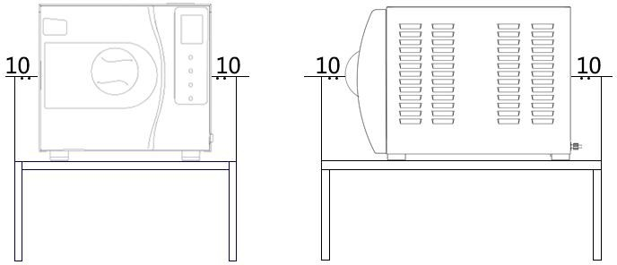

The sterilizer should be set in a place with good ventilation. The temperature of environment:0-55℃.
The humidity of environment: ≤85% Atmosphere pressure:500Hpa～1060Hpa An earth connection is essential

CAUTION DO NOT PUT ANY STUFF WHICH EASILY TO BE THAWY NEAR THE STERILIZER.

Set
- The sterilizer should be set on an aclinic table or place. Front part should be higher than back, it could adjust by the front bottoms of the sterilizer.
- The sterilizer cooling and vent area should not be jamed or blocked.
- Do not put any stuff on the top of the sterilizer.
- Do not put any stuff in front of the door, to avoid accident when open the door.
- Do not put any corrosive stuff near the sterilizer to avoid accident or risk.

Power Connection
- The sterilizer should be connected with a stable and separated power source
- Power socket is at the back of the sterilizer
- Please confirm the connection power is complied with specification of nameplate at the back of sterilizer

CAUTION DO NOT BEND THE POWER WIRE TO AVOID DAMAGE OF POWER WIRE DO NOT PUT ANY HEAVY STUFF ON THE POWER WIRE TO AVOID DAMGE OF POWER WIRE

DO NOT USE OTHER POWER WIRE TO AVOID DAMAGE OF STERILIZER DO NOT TRY TO ADD THE POWER WIRE TO AVOID ACCIDENT AND RISK


Wrong Wrong Right

Chapter 4 Description And Specification

Front View of the Sterilizer

2
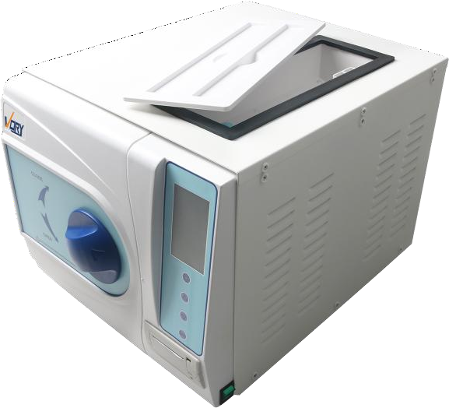
3
1
4
5

Name | Description
1． Displaying Window and control panel | It will show temperature, pressure or other sterilization  information on the window, easy for you to operate during the working.
 | Operation button to control the process of unit
2．Distilled water tank | Manually
3．Door Handle | Handle Pull out door with safe door locker to open and  close the door.
4.Printer | Print sterilization data
5.Power Supply Switch | Standard green power switch

Rear View of Sterilizer
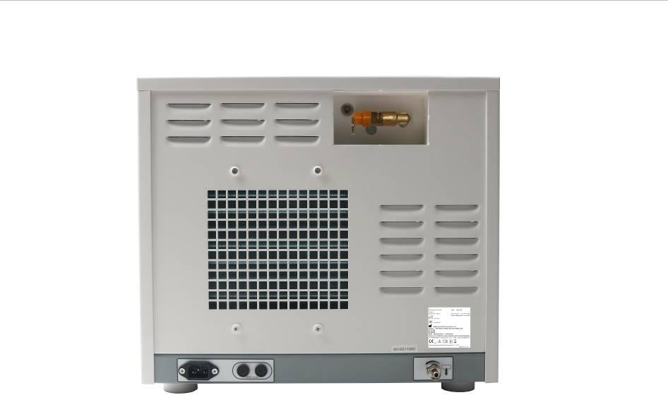
3

6
2
4
1
5

Name | Description
1．Power socket | Connected power source
2．Fuse | Protect product when the power is not stable.
3．Relief Valve | Protect pressure inside chamber over the working  pressure.
4．Nameplate | Basic information of manufactory
5. Drainage Port | For Distilled water tank
6. Air Filter | Filter the air and ensure air into chamber is clean

Opened Vew of Sterilizer

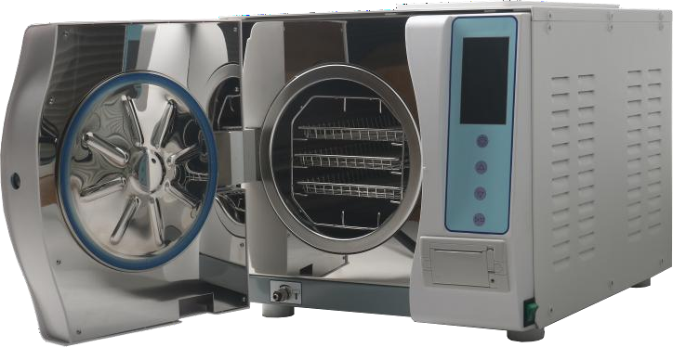
3 2
1
4

Name | Description
1. Door Gasket | For sealing the door
2. Tray Holder | To load the sterilized instrument
3. Anodized aluminum trays | PLACE THE Anodized aluminum trays
4. Drainage Port | For used Water tank

Outside Size

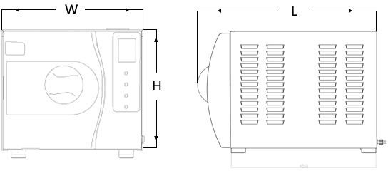

Item 7L Model 10L Model
12/18L Model(L*W*H) 540mm X 442mm X 380mm
23L Model(L*W*H) 660mm X 442mm X 380mm

Loading Size
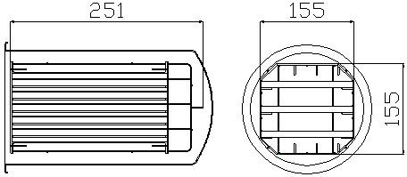
The loading size of sterilizer as followed:
L
W

12L Model(WXL)170X294 18L Model(WXL)225X294 23L Model(WXL)225X390

Specification

Basic specification
Rated Voltage: a.c220V~240V,50Hz
Rated power: VORY-23B: 2300VA VORY-18B/12B :1800VA Fuse: ~250V T10AL
Operation temperature: 0～55℃
The board affording weight: 4000 N/m² Noise :< 70db
The maximum capacity of a plate:1000g
The frequency of water draining: once a day, drain the water once you find the “water2” location on the screen display ”FULL
The maximum duration of using loading test: 90mins.
The maximum thermal radiation energy under the condition of 20℃~26℃:<2000J.

Sterilizer chamber:
Material: stainless steel (for medical) Max. Work Pressure: 300KPa
Min. Work Pressure: -90KPa Max. Temperature: 145 ℃
Chamber volume: 23L: 245mm X450MM 18L: 245mm X350MM 12L: 200mm X360MM Loading size: 12L:Model(WXL)170X294 18L:Model(WXL)225X294 23L: Model(WXL)225X390
Max. Loading weight: 12L (4kg/cm2) 18L (5kg/cm2) 23L (6kg/cm2)
Working Pressure/Temperature: 90～130KPa/121℃~122℃；200～230KPa/134℃~135℃ Water volume for one cycle: 0.16L（min）0.3L（max）

Sterilizer steam safety valve:
Safety release pressure: 240KPa Max. Working temperature: 160 ℃

Water tank

Distilled water tank volume: 23/18/12L (3L)

CAUTION WATER ADD INTO MAIN WATER TANK MUST USE DISTILLED WATER!

AND WATER TEMPERATURE MUST UNDER 40℃。

Used water tank volume: 23/18/12L (3L)

Test Method
Vacuum Test B&D Test

Sterilization Cycle
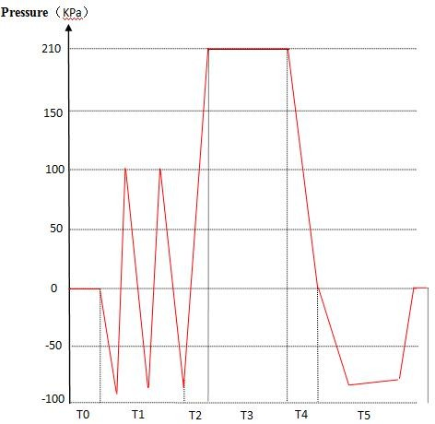

T0. pre-heating T1. pre-vacuum
T3. sterilizing T4. air-discharging T5. drying
T0-T5. entire duration

Table—Types of sterilization cycles

Type | Description of intended use
B | The sterilization of all wrapped or non-wrapped, solid, hollow load products type A  and porous products as represented by the test loads in this standard.
S | The sterilization of products as specified by the manufacturer of the sterilizer including non-wrapped solid products and at least one of the following: porous products, small porous items, hollow load products type A, hollow load products B,  single wrapped products, multiple-layer wrapped products.
NOTE 1 | The description identifies ranges of products and test loads.
NOTE 2 | Non wrapped sterilized instruments are intended either for immediate use or for non  sterile storage, transport and application (e.g. to prevent cross infection).

Chapter 5 Panel And Functions

Controlling Panel
    - Integrated display
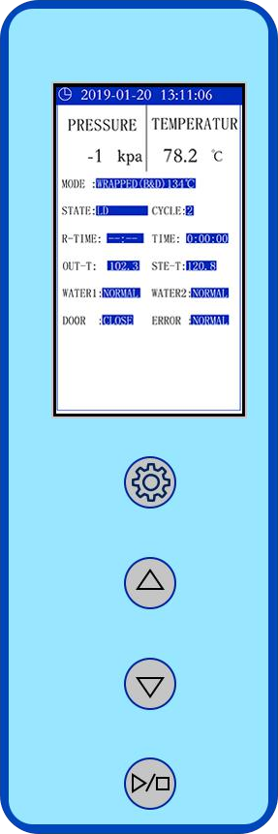
- Display the system time
- Display the chamber pressure, unit is:KPa
- Display the chamber temperature, unit is:℃
- Display the current operating mode
- Display the current work status
- Display the running total cycle
- Display the heating ring and steam generator temperature
- Display the distilled water tank and Main Water tank level

Display the door status

Display the error code
    - up choosingbutton
Up choosing has the function that is used for setting down the cycle program. In the program menu, press this button to choose the programs by up direction.
    - down choosingbutton
Down choosing has the function that is used for setting down the cycle program. In the program menu press this button to choose the programs by up direction.
    - Button
Program setting button, press this button , it will enter into the parameter setting page, and then please
press or button to choose the cycle program as you need.
    - Button
This button is used for confirmation on the start. After you choosing a certain program, please press this button to confirm it. Press the machine again will start a working cycle. And if press this button for 5 seconds it would stop the working cycle immediately

CAUTION PLEASE CONTACT YOUR DISTRIBUTOR OR AUTHORIZED PEOPLE WHEN ERROR CODE IS DISPLAYED.

Menu

mode menu
Turn on the power, press button to enter the parameter setting page, it is the sub-menu list.

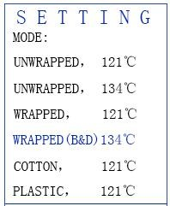 | Unwrapped , one time vacuum; working temperature 121℃ or 134℃; working pressure 110KPa or 210KPa; sterilization cycle time 121℃/20 or 134℃/4 minutes; and drying time 121℃/15 or 134℃/12 minutes.
 | Wrapped. three times vacuum; working temperature 121℃ or 134℃; working pressure 110KPa or 210KPa; sterilization cycle time 121℃/20 or 134℃/4 minutes; and drying time 121℃/15 or 134℃/12 minutes.
 | Cotton. Three times vacuum, working temperature 121℃; working pressure 110KPa; sterilization cycle time 20 minutes; and drying time 15minutes.
 | Plastic. One time vacuum, working temperature 121℃; working pressure 110KPa; sterilization cycle time 20 minutes; and drying time 15 minutes.

Press or botton to choose the program, Press button to confirm.

system Set

Turn on the power, press button to enter the parameter setting page

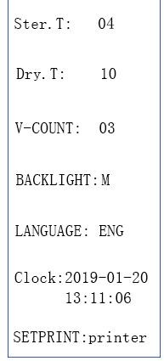 | Press or botton to choose the Ster.T, and press to confirm. after then press  or to adjust, last press to confirm
Press or botton to choose the Dry.T, and press to confirm. after then press
or to adjust, last press to confirm
Press or botton to choose the V-COUNT, and press to confirm. after then press or to adjust, last press to
confirm
Press or botton to choose the BACKLIGHT, and press to confirm. after then press or to adjust, last press to
confirm
Press or botton to choose the LANGUAGE, and press to confirm. after then press or to adjust, last press to
confirm
Press or botton to choose the CLOCK, and press to confirm. after then press or to adjust, last press to
next ,until the second set finish
Press or botton to choose the PRINT, and press to confirm. after then press
or to adjust, last press to confirm

Chapter 6 Operation Process

Power On
Please connect the power cord before you start the operation. The power switch to control the unit turn on or off. It is located back right corner of the sterilizer. When you turn the power on, the sterilizer is originally state showing the last sterilization program and opening alarm “Please open the door before working”. If the door closed before turn on power, you should open the door at power on state, and then go to the next step.

Distilled Water Adding
After you connecting to the power and select the corresponding program, if the “water2”location on the screen display ”EMPTY”, which means the water in the water storage tank is of its lowest level and you have to add water in.
Pic 6-1

The “water2” location on the screen display ”EMPTY” when the water is not enough for next cycle.

if the “water2” location on the screen display ”EMPTY”, though you choose program and press start button, it will not work either, so you need to add distilled water in until the “water2” location on the screen display ”FULL.

You can fill in water manually on the right top of the machine. Open up the top cover, to fill in water according to the front view, stop filling in water when the “water2” location on the screen display ”FULL.

If the water shortage alarmed during the sterilizing, you should not worry about it, the water will not influence this process. The water that had been left in the tank is adequate for the operating cycle, but it can not be runned for next cycle.

Water Quality
The distilled water supply shall be according to the table below:
 | Contaminants in  water supplied to generator/chamber | Contaminants in  condensate at steam inlet to sterilizer
Evaporate residue | ≤ 10 mg/l | N/A
Silicate (SiO2) | ≤ 1 mg/l | ≤ 0.1 mg/l
Iron | ≤ 0.2mg/l | ≤ 0.1mg/l

Cadmium | ≤ 0.005 mg/l | ≤ 0.005 mg/l
Lead | ≤ 0.05 mg/l | ≤ 0.05 mg/l
Rest of heavy metals except iron,  cadmium, lead | ≤ 0.1 mg/l | ≤ 0.1 mg/l
Chloride (Cl) | ≤ 2 mg/l | ≤ 0.1 mg/l
Phosphate (P2O5) | ≤ 0.5 mg/l | ≤ 0.1 mg/l
Conductivity (at  25°C) | 3 to 15 μs/cm | ≤ 3 μs/cm
pH value (degree of  acidity) | 5 to 7.5 | 5 to 7
Hardness (Σ ions of  alkaline earth) | ≤ 0.02 mmol/l | ≤ 0.02 mmol/l
Appearance | Colorless, clean, without sediments

CAUTION The use of water for autoclaves that do not comply with the table above may have severe impact on the working life of the sterilizer and can invalidate the manufacturer’s guarantee.

Use only deionized water, having a maximum conductivity of 15

μs/cm. Conductivity greater than 15 μs/cm may cause failures.

DO NOT TILT THE STERILIZER WHEN THE RESERVOIR IS FULL OF WATER.

Alarming If Used Water Reservoir Is Full

if the “water1” location on the screen display ”FULL” during the sterilizing, which means that the used water reservoir needs to be drained out.
Connect the water tube to the machine left lower corner inlet connector, please see 4.3

Drainage Port for used water tank

Water has been drained when it reaches the maximum temperature, 70℃，if it is higher, you need to check whether the fan operates normally, or contact the local distributor immediately, we will offer our best service to you in no time.

Selecting Sterilizing Program

Please check the LCD screen without any alarm information before selecting the sterilizing program.

pressing button to enter the parameter setting page, Select the sterilizer program which you want.

Loading Instrument
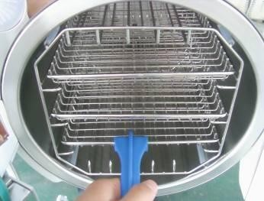
Instruments should be put on the instrument trays with some gap between each instrument so that the steam can be ventilated freely. Please use the attached handle tool to load instrument trays into chamber to avoid scalding .（pic 6-2）

（pic 6-2）

Arrangement on Trays Before Sterilization

- Read the following instructions for proper usage and maintenance of instruments and material.
- Make sure that the instruments of different materials are separated and placed on different trays.
- In case of carbon steel instruments, place a towel or paper-wrap between the tray and the instruments in order to avoid a direct contact between different materials.
- All the instruments must be sterilized in an open position.

- Make sure that the instruments remain apart during the sterilization cycle.

- Do not overload the trays in order foe items to be properly sterilized and dried.

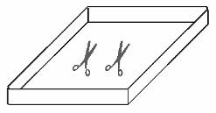
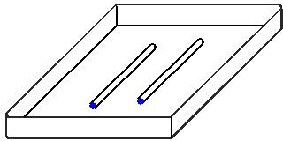
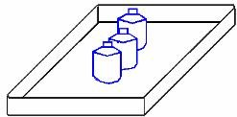
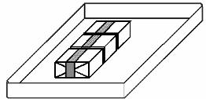
Drawings explain: RIGHT

UNRIGHT

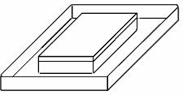
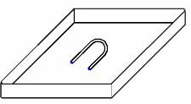
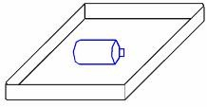
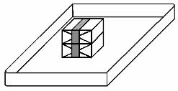
CAUTION RECOMMENDED TO CLEAN THE INSTRUMENTS BEFORE LOADING.

ATTENTION IT IS MUCH HELPFUL TO TURN ON POWER FOR WARMING 5 TO 10MINS BEFORE RUNNING PROGRAM, IF THE TEMPERATURE OF ENVIROMENT IS UNDER 10 DEGREE

Closing The Door

Close the door after loading the instruments which need to be sterilized. Rotating the handle to the left, out like picture showing, push the door and then rotating the handle to the right as picture showing the position of the door on the “LCD” will display open if the handle did not be closed fully.
When close the door, however, if the chamber is warm and steam still be left in it, you may feel a strong resistance when you close the door. You just have to push harder and latch the handle completely. You may also leave the door open to release the steam and kindly close the door

again. Or you can push the door hardly in while you turn the door handle. If you still unsure the door has been closed properly, you can also adjust the door (refer to adjusting the sterilizer door)

Drawing Explanation
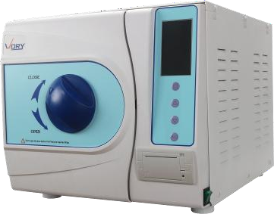

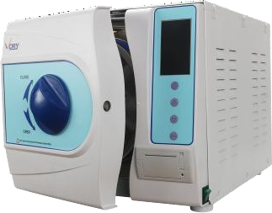

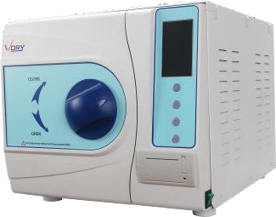

WRONG WRONG RIGHT

Attention THE LCD WILL DISPLAY OPEN IF THE DOOR IS NOT CLOSED FULLY, THE STERILIZER WILL NOT RUN UNLESS THE DOOR HAS BEEN CLOSED COMPLETELY. IF THE DOOR HAS BEEN OPENED DURING THE CYCLE, THE STERILIZER WILL DISPLAY: DOOR IS OPEN DURING THE CYCLE! IF SO, PLEASE TURN OFF POWER SWITCH TO CANCEL THE ALARM, THEN CLOSE THE DOOR COMPLETELY AND RESTART.

Starting A Working Cycle

Ensure the door is closed completely, then you can press button to start a working cycle,
the LCD will display the cycle state. The sterilizer will heat, sterilize and drying the instruments automatically for you. The whole process will take 40-60 minutes. It depends on the object being sterilized, the initial temperature, and the program you selected.

The Process of Sterilization as followed:

Pre-heating: Display HEAT.
Chamber will start to be pre-heating when you are turning on the power switch, and keeping the chamber warm.

Pre-vacuum: Display VACUUM.
Outputted the air in the chamber, and inputted steam in the chamber, run 3 cycle times.

Exhausting: Display down
Exhausting high pressure air inside chamber.

Heating: Display up.
Keep heating until getting the correct temperature and pressure

Sterilization: Display STER
Display sterilizing time and temperature. The sterilizer keeps the temperature of sterilization with time is counted down.

Vacuum drying: Display DRY
Releasing pressure until the pressure down to the 0 KPA
Display dry time and the temp. Draining used water and steam. Sterilizer will automatically switch to vacuum drying process after the steam pressure drop and chamber temperature down,

End: Display END.
The buzzer make a sound means the total sterilization processes have been finished, then wait for the pressure down to under “6” KPa at the LCD.

CAUTION DO NOT PUT OR COVER ANY STUFF ON THE MACHINE TO KEEP HEAT VENTING WELL.

End Of The Sterilization Working Cycle.
When working cycle has been finished, the LCD Screen will give you a sound of alerting, and then you can open the door and take the sterilized instruments out.

WARNING DO NOT TRY TO OPEN THE DOOR IF THE PRESSURE INSIDE CHAMBER DOES NOT SHOW UNDER "6 KPA".

When the door of sterilizer has been opened, the program will return to the initial state, heat-preserving and waiting for next sterilizing cycle, before start a new program it will be kept in a heat-preserving condition all the while.

CAUTION AFTER STERILIZING HAS BEEN FINISHED, PLEASE USE THE MATCHED INSTRUMENT HAND TONG TO TAKE THE INSTRUMENT PLATES OUT FROM STERILIZING CHAMBER. IT WILL BE BETTER TO STORE STERILIZED INSTRUMENT AFTER THEM HAVE BEEN COOLED DOWN TOTALLY.

Power Off

If you finished the sterilization, please turn off the power switch, the power switch light will be off, and close the door but not lock it.
If you will stop use it for a long time or for storage, please unplug the power cord.

ATTENTION DURING THE STERILIZING, WE SUGGEST YOU THAT YOU SHOULD USE THE SPECIAL PAPER WHICH CAN INDICATE THE EFFECT OF THE STERILIZATION OR STERILIZATION BAG WHICH HAS THE EFFECT INDICATION OF STERILIZATION, PUT THEM IN THE CHAMBER TOGETHER WITH THE STERILIZATIONS IN ORDER TO ENSURE RELIABILITY OF STERILIZATION.

Abnormal Exiting

In the cycle, if the program is interrupted by the error it will enter “Abnormal Exiting program” The error code display window it will display E99
Error No.99 means the abnormal exiting by user. Press to run vacuum pump enter the
3mins dry program, to ensure that the water inside the chamber is totally draining out. Then skip to original state, remind you to open the door, open and close the door then to go to the next sterilization cycle.

WARNING DO NOT TRY TO OPEN THE DOOR IF THE PRESSURE INSIDE CHAMBER DOES NOT SHOW UNDER "6 KPA".

Sudden Power Off
During the cyle, if power is sudden interrupted, then the power reconnect, the window will be showing the last state during the cycle with current temperature and pressure. The error code display window it will display E98
Error No.98 means the sudden power off happen during cycle. Press to run vacuum
pump enter the 3mins dry program, to ensure that the water inside the chamber is totally draining out. Then skip to original state, remind you to open the door, open and close the door then to go to the next sterilization cycle.

WARNING DO NOT TRY TO OPEN THE DOOR IF THE PRESSURE INSIDE CHAMBER DOES NOT SHOW UNDER "6 KPA".

Chapter 7 Essential Information

Please to ensure the sterilizer continues to operate correctly, it is very important to follow points and to carry out the necessary care and maintenance procedures as specified.

Please Ensure The Following....

- You have read and follow these operating instructions.

- The load is suitable for sterilizing in the cycle selected.

- The load can be sterilized at the selected temperature.

- The load has been rinsed thoroughly in clean water before sterilization to avoid any chemical residues left after cleaning contaminating the sterilizer.
- When placing instruments on trays, ensure that they are placed on the ribs of the tray (to help drainage), they must not touch each other and must not interfere with other trays or the chamber above.
- Only distilled, de-ionized or sterile water can be used.

- The sterilizer should be set in a ventilated area.

- The sterilizer is not installed in an enclosed cupboard space.

- Keep the door ajar if not in use.

- Only qualified personnel could do the service of sterilizer.

- Keep and reserve the package for transportation

And Please Do Not....

- …lose this manual

- …add any chemicals or whatsoever analogous water to the sterilizer.

- …attempt to sterilize volatile substances, toxic materials or other unsuitable loads. Refer to your “Responsible Person” for advice.
- …place the sterilizer in direct sunlight.

- …place the sterilizer on heat sensitive surfaces.

- …use inappropriate cleaning materials.

- …drop or abuse the sterilizer.

- …use in areas of risk associated with flammable materials or gases.

Chapter 8 Maintenance

Maintenance Schedule Chart

Maintenance Required | Person Responsible
Daily
Clean Door Gasket | User
Clean Chamber | User
Weekly
Clean Chamber, Trays and Rack | User
Clean Water Draining Filter | User
Monthly
Clean Reservoir | User
Yearly
Performance Verification and maintenance | Qualified service personnel
As Required
Change Door Gasket | User
Cleaning function | User

Daily Maintenance

Cleaning Door Gasket

The door gasket and the mating surface should be wiped off clean each day with a clean, damp cloth. Do not use abrasive cleaners on the gasket or mating surface.
Use warm soapy water for keeping marks of sterilizer persistent, but ensure any soap residues are completely removed by wiping both the gasket and the vessel again with water using a lint free damp cloth.

WARNING Refer to qualified personnel for servicing： Never use a wire brush, steel wool, abrasive material, or chloride-containing products to clean door and chamber assembly. “Caution hot surface. Avoid contact." ensure that the sterilizer is cooled down fully before cleaning to avoid burns.

Cleaning After Liquid Loads

Biological media tends to boil at a higher rate than other liquids during venting. This causes media to be spattered inside the chamber. Therefore, the chamber must be cleaned daily when you are sterilizing media. Cleaning as follows:

- Allow unit to be cooled down.

- Wipe out chamber and door with a clean, damp cloth.

WARNING Failure to keep the interior of the stainless steel chamber free of mineral deposits and debris can cause premature failure of the sterilizer.

Weekly Maintenance (More Often If Necessary)

Cleaning Chamber, Trays and Rack

At least once a week, the trays and tray rack should be removed from the sterilizer chamber. The trays, tray rack and chamber should be thoroughly cleaned to remove any deposits from the surfaces.
Clean the trays, rack and chamber (especially the bottom of the chamber) with appropriate antibiological cleaners. Wipe all residues from the surfaces with a dampened, lint-free cloth.

WARNING To prevent from collection of mineral deposits and corrosion of chamber components, use distilled or deionized water only as specified. Clean chamber after each use if sterilizing saline solutions.

Cleaning water draining filter (pic 8-1)

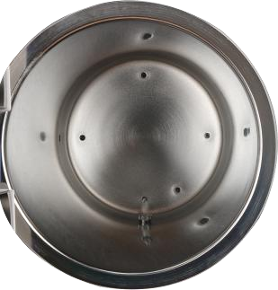

pic 8-1

Water draining filter might has been jammed by some dust because of use for a long-term, so effect of vacuum and drying would be influenced. Some tiny impurity might be deposited on the filter after a long-term use, blocking the filter, so as to influence the effect of the vacuuming and water discharging. The kinds of impurity come from smeary dust on the instruments being

sterilized or some calcification in the water.

Keep cleaning of the inside chamber in order to make life-time of filter much longer; please take the following advice for consideration:
- Use eligible distilled water;

- The instruments should be cleaned before placing in; it is good to use specified packing for the instruments with oil or other impurity, don’t forget to seal up.
- Rotate the water filter which composed by filter net tube(A) and filter holder(B) inside the chamber. Cleaning the part A and B, ensure that there is no any dirty thing on it.( We suggest you to clean by ultrasonic cleaning machine). Then set it back and rotate to the hold bottom of the chamber.

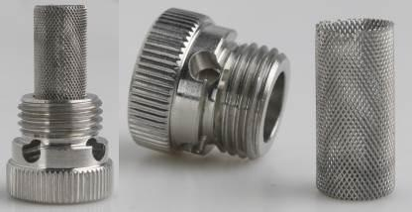
(pic 8-2)
A
B

Monthly Maintenance

Cleaning Reservoir

There are some impurities and some toxins had been left behind in the reservoir because distilled water had left behind for a long time, so you need to drain and clean regularly. According to the position shown in 4.1(2)” Distilled water tank”, open the cover to clean inside.

ATTENTION BE SURE THAT USE DISTILLED WATER PROPERLY IN ORDER TO EXTEND THE STERILIZER LIFE-TIME.

DO NOT RAVE ABOUT THE STERILIZER WHEN THE TANK HAS BEEN FILLED.

DO NOT ADD MORE THAN 7 LITERS OF WATER TO THE RESERVOIR AFTER CLEANING.

Maintenance To Be Done As Required

Changing Door Gasket

Tool：a plain screw driver without sharp head is needed.

Disconnect the sterilizer from the power supply. Ensure that the sterilizer is cool and depressurized.
- Hold verge of the seal by one hand softly, and another hand should be inserted the screwdriver into the gap between gasket and door, take out the seal slowly.
- Once you take out one part of the seal, you can draw out the whole seal slowly. After taking out the seal, please check and clean the groove of gasket, so does the gasket, please replace the gasket if there is some damage.
- Fix the clean gasket in initial door groove. Attention: the gasket should be imbedded in the groove equably. At first, please imbed the 4 spots equably into groove when fix the gasket, and then embed the other parts. After that, press the gasket equably by hand.
- Attention: the inner edge of gasket may be ectropium during embedding it in the door groove, at this time; you’d better to tight it back to the groove by using the screwdriver carefully.

1 2
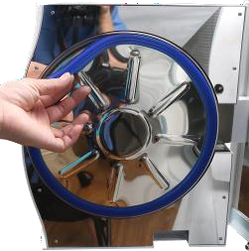
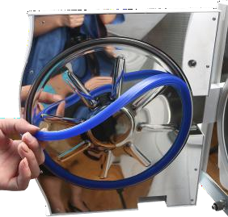
3 4
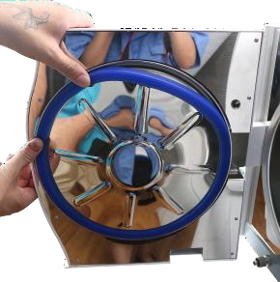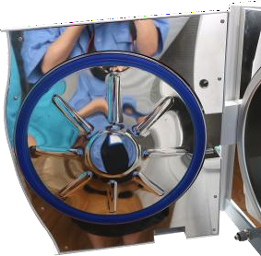

Chapter 9 Servicing By The Approved Technician

Service is essential for consistently effective sterilization.

We recommend servicing by an approved technician every 2 years.

Check-list:

Checking the solenoid valves.

Checking the water pump.

Checking the vacuum pump.

Checking the distilled water drain valve and the used water drain valve.

Checking the relief valve.

Checking the door locking system.

Checking the sensor of the pressure and temperature.

Checking the sensor of the water level.

Checking the electrical connections.

Checking the hydraulic connections.

Checking the safety thermostat.

Cleaning the sterilization chamber.

Cleaning the trays and the tray holder.

Cleaning the reservoirs.

Replacing the water filter.

Replacing the air filter.

Replacing the door gasket.

Chapter 10 Transportation And Storage

Preparation Before Transportation And Storage
Shut off the power switch, unplug the cord, and make the sterilizer been cooled down completely.

Draining

Drain water from reservoir and the condensate collector completely: insert the joint end of the attached tube to drain connection. (See 4.2 Distilled water tank and 4.3 used water tank )

Conditions For Transportation And Storage
Temperature: -5 ℃ ~ +55℃ Relative Humidity: ≤85%
Atmospheric pressure: 500HPa~1060HPa

Package
Package is used in transporation for protecting product, conveniently delivey and sales. The sterilizer package requirement should as followed:
- Product can not over 3/4 valume of package

- Product should be fix inside the package

- Package bag should be higher than product 6mm

Appendix 1 Instrument Which Need To Sterilize

The instrument should be treated as followed process:

- Clean the instruments, keep them dry

- Packing the instrument into sealing bag( if need)

- Put instrument into sterilizer

- Run appropriate sterilzation program

- Take out and store

CAUTION THE STERILIZED INSTRUMENT SHOULD CHECK THE BAG OF INSTRUMENT WITHOUT DAMAGE OR AVULSION.

THE STERILIZED INSTRUMENT STILL WITH HIGH TEMPERATURE SHOULD NOT STACK, TO AVOID BAD HEAT RADIATION.

Appendix 2 Error Code List

The sterilizer will show Error information when some problem with sterilizer.

Drawing Example


Error Information

Error Code List

Error  Code | Error Information | Remark
E0 | Temperature sensor in Chamber surface problem
E1 | Chamber inside temperature over
E2 | steam generator temperature over
E3 | Pressure and temperature can not match
E4 | Failure to keep sterilization temperature and pressure
E5 | Door opened during cycle
E6 | Working over time
E7 | Pressure can not be exhausted

Appendix 3 Main Parts

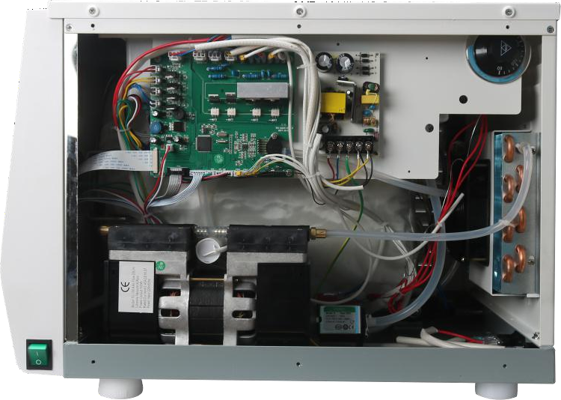

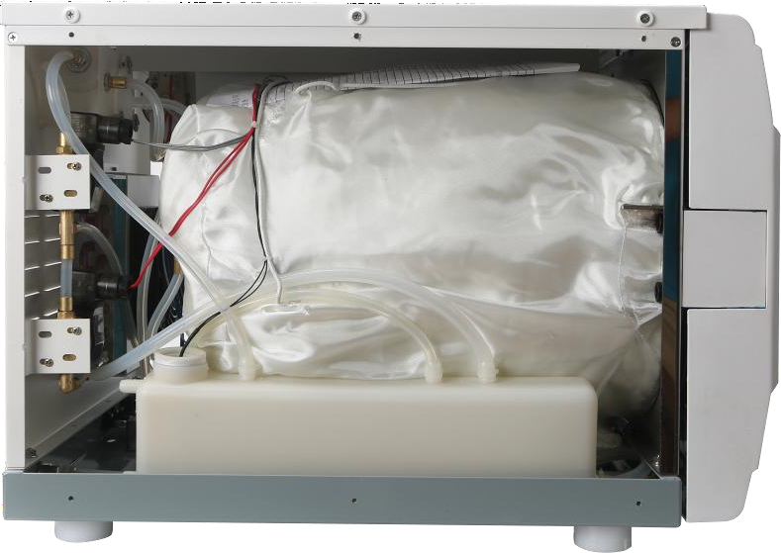

Appendix 4 Electric And Hydraulic Drawings

Hydraulic Drawing
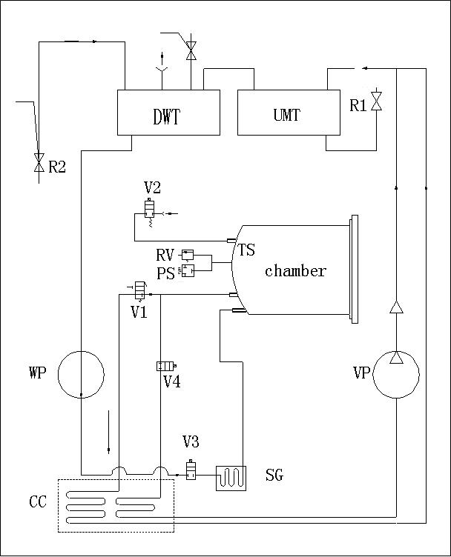

UMT | The Used Water Tank
DWT | The Distilled Water Tank
V1 | Air Outlet Valve
V2 | Drying Air Inlet Valve
V3 | Chamber Water Inlet Valve
V4 | Vacuum Valve
PS | Pressure sensor

WP | Water Pump
SG | steam generator
VP | Vacuum Pump
RV | Relief Valve
R1 | Used Water Drain Port
R2 | Distilled Water Drain Port
CC | Condensate Collector
TS | Temperature Sensor

Electric Drawing
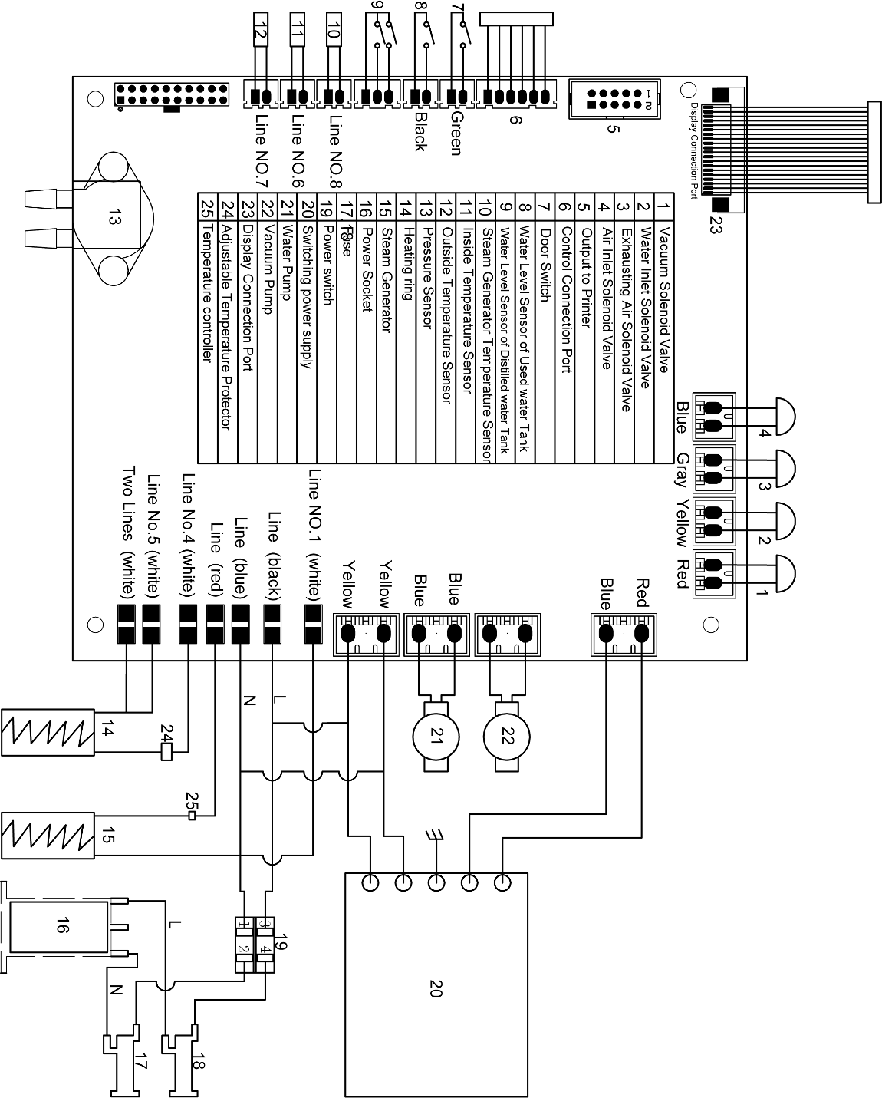

Appendix 5 The Standards Of Testing

NO. | Testing item | Request of standards
1 | Shape | The shape of sterilizer should be tidiness and mustn’t have the disfigurements, such as deflection, hollowness, collision, nick, sharp edge, and so on.
2 | Out-veil | The out-veil should be assured to disassemble easily in  order to repair the equipment.
3 | Letter marker | The letter marker in panel of sterilizer should be legible.
4 | Electroplate components | The Electroplate should accord with YYOO76-1992  class 2, which for the request of aspect.
5 | Printer components | The Printer components should accord with YY1055-1999 the class Ⅱ which for the request of  aspect.
6 | Door safe lock | On the normal condition, if the sterilizer door hasn’t  been locked tightly, the program can not start.
7 | Chamber Pressure | The door should ensure that the door can’t be opened  when the chamber pressure over than 20Kpa.
8 | Relief Valve | Sterilizer have to install relief valve, when the pressure range from 0.24Mpa±0.01Mpa that the relief can be opened, and when arrive at the seting pressure, the air relief valve will open automatically and discharge  pressure.
9 | Sterilizing Program | Sterilizer should have the pre-established program  about 121℃ and 135℃ ,dressing and instruments.
10 | Controlling system | The control system in sterilizer should limit the steam which in the chamber be controlled at the highest average temperature in ±3 ℃ of pre-establish station. And ensure the temperature value accords with the  pressure controlling value.
11 | Timing control | It’s possible that the sterilization and drying can be  timing control, and the windage should be limited that smaller than 10% of pre-establish value.
12 | Button and Switch | Buttons and switches should be flexible and reliable on the sterilizer.
13 | Indicator and display | The indicators and displays of sterilizer should show the states of every sterilizing procedure exactly. Under the normal situation, sterilizer should indicate:  - Chamber temperature  - Chamber pressure  - Sterilizing work state  - Water level state  - Station of the opening or closing door

14 | Quantum of leak | on the condition of the vacuum - 0.07 Mpa, the sterilizer  shouldn’t leak 0.013Mpa within ten min.
15 | Leak forbid | The sterilizer can’t leak under the work pressure
16 | protective earthing impedance | The impedance between protective earthing point of the  power input faucet and protective earthing can be touched all metallic parts, doesn’t over than 0.1Ω.
17 | Dielectric strength with Working Temperature | a) A-al: It should bear the sine wave test alternative voltage ,50Hz, 1500v, which between the web power input port and protective earthing can be touched all metallic parts. It lasts 1 min, and hasn’t the  phenomenon of breakage and flashover
17 | Dielectric strength with Working Temperature | b) A-a2: It should bear the sine wave test alternative voltage, 50Hz, 1500v, which between the web power input port and the enclosure of which isn’t be pretended earthing. It lasts 1 min, and hasn’t the phenomenon of  breakage and flashover
18 | No-load | For all loads except hollow load A, the presence of saturated steam in the usable space and the load is deemed to have been achieved when, throughout the holding time, all temperatures measured in the usable space and the load: (Attention: the theory of steam temperature is accounted by measuring pressure, which  can be considered the test temperature.)
18 | No-load | are not lower than the sterilization temperature;
18 | No-load | are not more than 4 K above the sterilization  temperature;
18 | No-load | do not differ from each other by more than 2 K.
18 | No-load | The usable place temperature during the no-load can  not over than the scope of highest temperature.
19 | Hollow load | The hollow load A and B, As for testifying whether the saturation steam existing is relevant to the color change, by distinguish used chemistry direction system whether it was according to the direction system  manufacture
20 | Dryness, solid load, double wrapped | For wrapped loads, any remaining moisture shall not lead to wet packages and shall not result in detrimental effects on the sterilizer load. Any remaining water droplets on the inner side of the film of laminate pouch  shall evaporate within 5 min.
20 | Dryness, solid load, double wrapped | For load the moisture content shall not exceed 0,2 %

